DBMS ASSIGNMENT PGCP-AC-
Submitted by: Vanita Dhage (268148)
PRN(260841220062)

Assignment 1 (DAY 1)

Question 1.

1.To list all records with sal > 2000 and comm>200
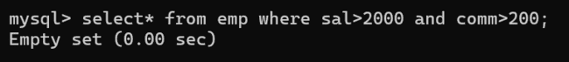

2.To list all record with job=’Clerk’ or sal>2000
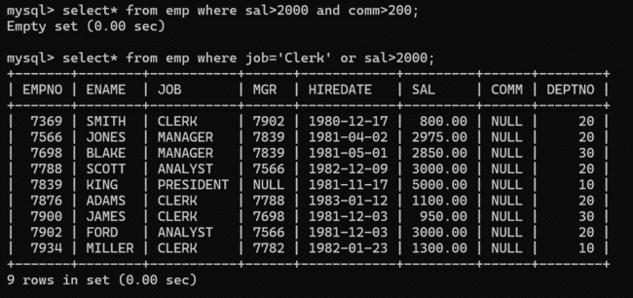

3.To list all the record with sal=1250 or 1100 or 2850
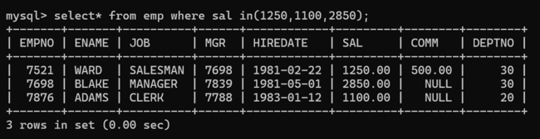

4. To list all employees with sal>1250 and <2850
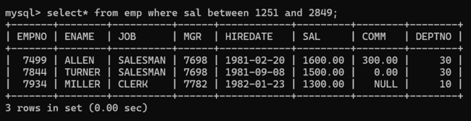

5. To list all employees with name ends with AS
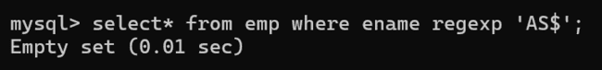

6. To list all employees with job starts with C and ends with K
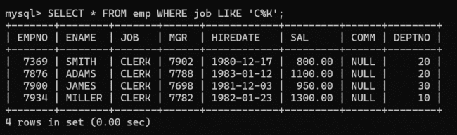

7. To list all employees with job contains L at third position and M at third last position
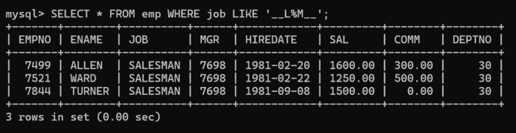

8. To list all the record with sal not equal to 1250 or 1100 or 2850
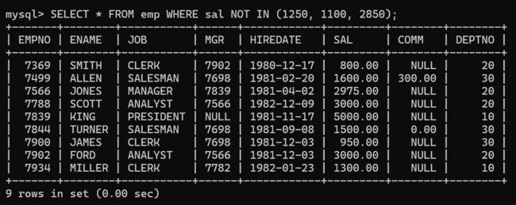

9. To list all employees with sal not >1250 and <2850
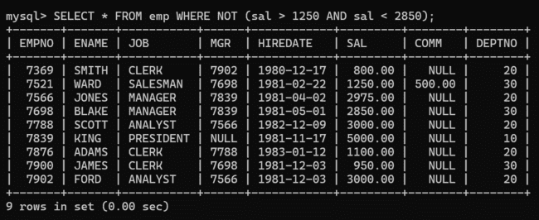

10. To list all employees with job starts with C , E at 3rd position and ends with K
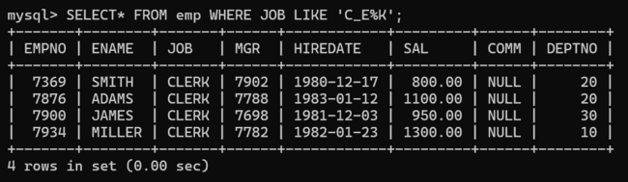

11. To list all rows with comm is null
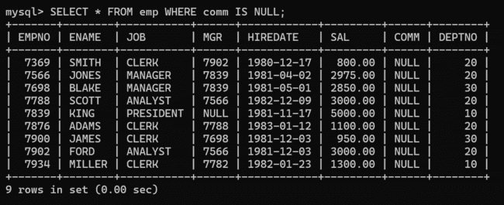

12. To list all employees with sal is null and name starts with ‘S’
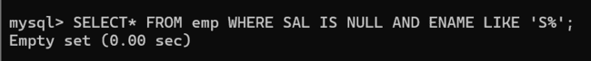

13. To list all employees with job contains 5 characters
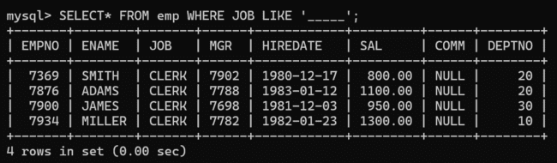

14. To list all employees with name contain ‘A’ at 1 position and job Contains 5 characters
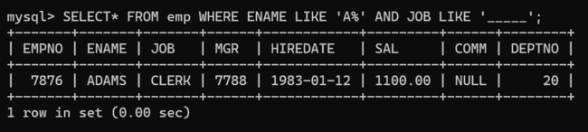

15. Retrieve the details (Name, Salary and dept no) of the emp who are working in
department code 20, 30 and 40.
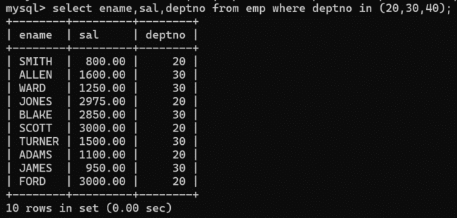

16. Display the total salary of all employees . Total salary will be calculated as
sal+comm+sal*0.10
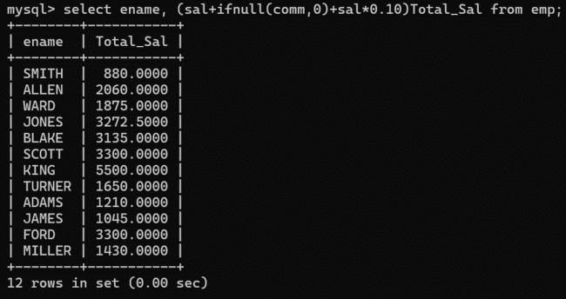

17. List the Name and job of the emp who have joined before 1 jan 1986 and whose
salary range is between 1200and 2500. Display the columns with user defined Column
headers.
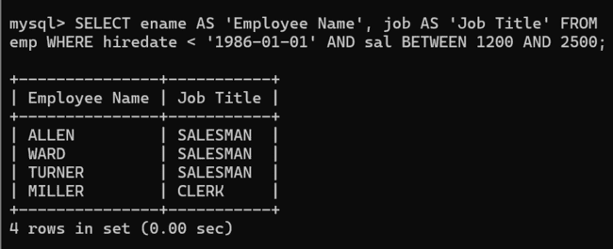

18. List the empno, name, and department number of the emp works under manager
with id 7698
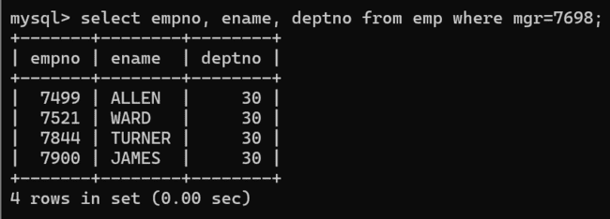

19. List the name, job, and salary of the emp who are working in departments 10 and
30.
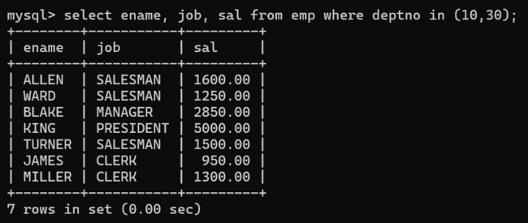20. Display the emp details who do not have manager.
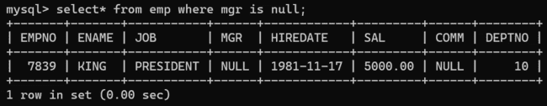

21. Write a query which will display name, department no and date of joining of all
employee who were joined January 1, 1981 and March 31, 1983.
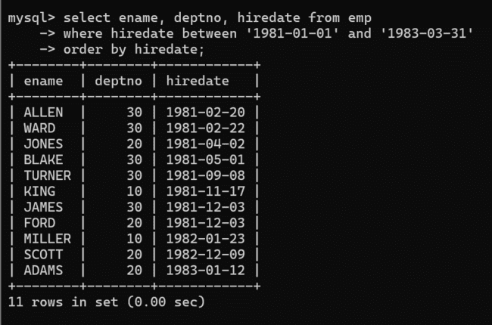

22. Display the employee details where the job contains word ‘AGE’ anywhere in the Job
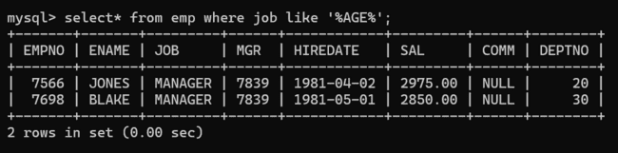

23. List the details of the employee , whose names start with ‘A’ and end with ‘S’ or
whose names contains N as the second or third character, and ending with either ‘N’ or ‘S’.
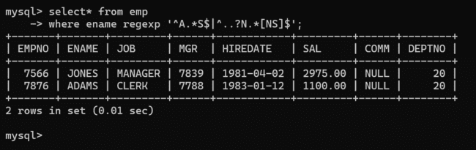

24. List the names of the emp having ‘_’ character in their name.
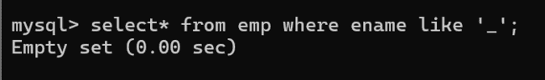
25.List all emplyees who joined in september.(without using functions)
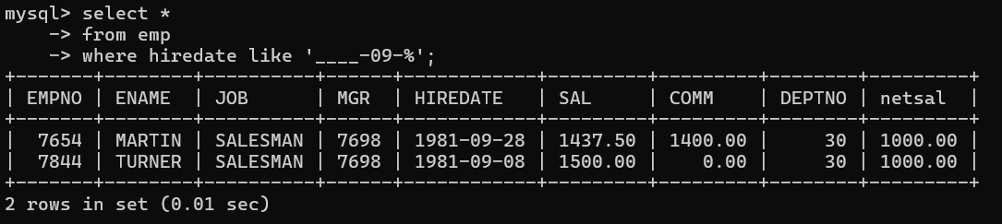

Single Row Functions

1. To list all employees and their email, to generate email use 2 to 5 characters from ename
Concat it with 2 to 4 characters in job and then concat it with ‘@mycompany.com’
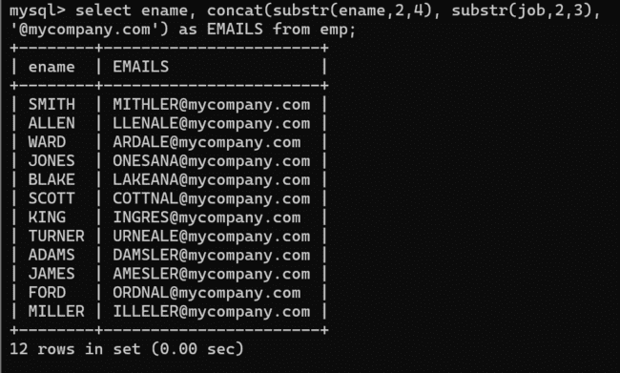

2. List the empno, name, and department number of the emp who have experience of 18 or
more years and sort them based on their experience.
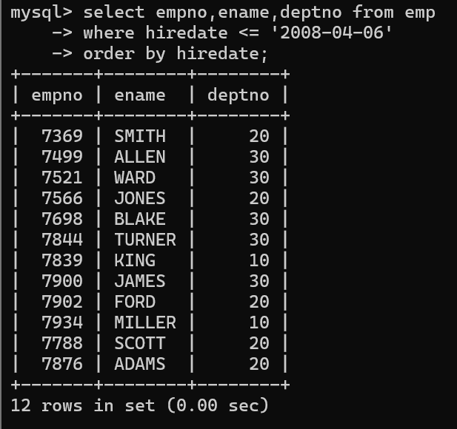

3. Display the employee details who joined on 3rd of any month or any year
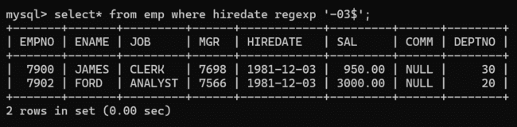

4. display all employees who joined between years 1981 to 1983.
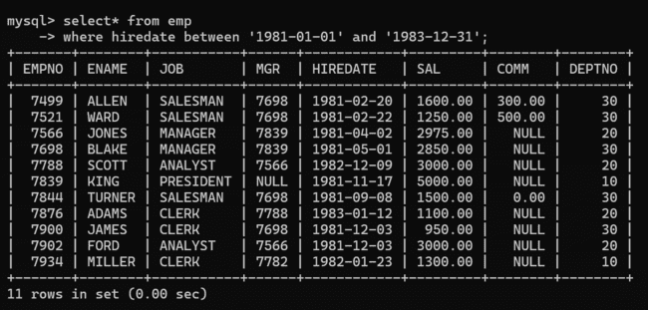

5. Display name concatenated with dept code separated by comma and space. Name the
column as ‘Emp info’.
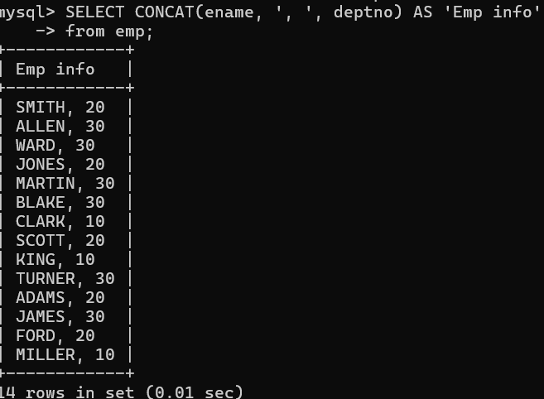
Group functions
6. Display the Highest, Lowest, Total & Average salary of all employee. Label the columns Maximum, Minimum, Total and Average respectively for each Department. Also round the result to the nearest whole number.
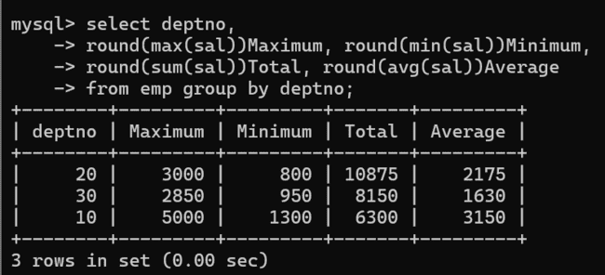

7. Display Department no and number of managers working in that department. Label the
column as ‘Total Number of Managers’ for each department.
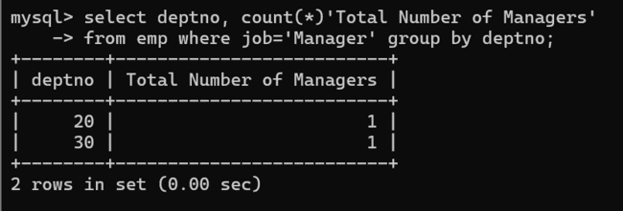

8. Get the Department number, and sum of Salary of all non managers where the sum is
greater than 20000.
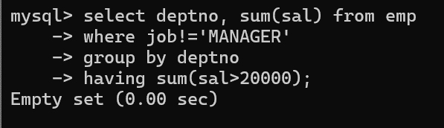
Product assignment
1. Display the product name and quantity of all products whose quantity is
greater than 20.
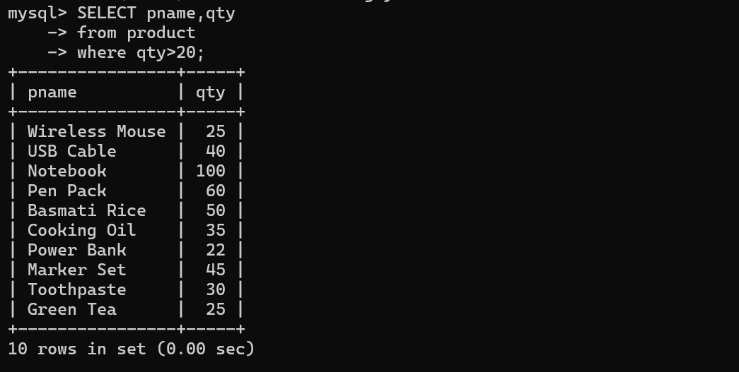

2. Display pid, pname and qty for products whose quantity is less than or
equal to 15.
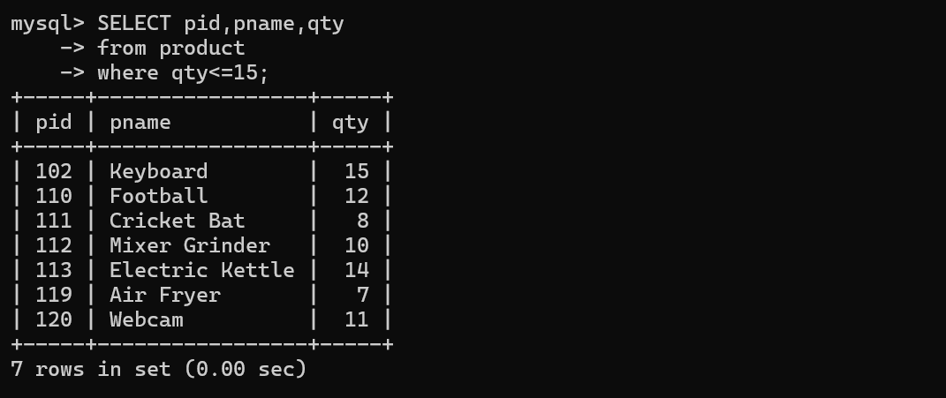

3. Display pname and a calculated column showing the quantity after adding
10 units to the current quantity.
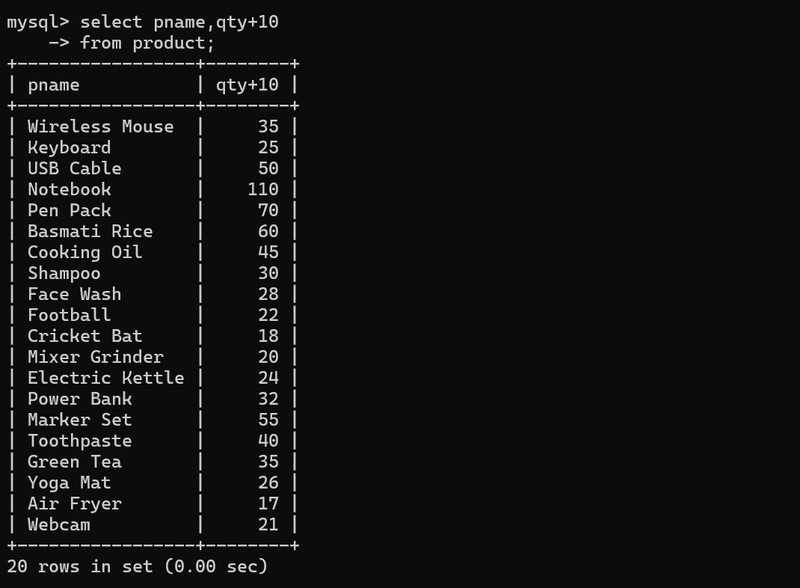
4. Display pname and a calculated column showing the quantity after removing
5 units from the current quantity.
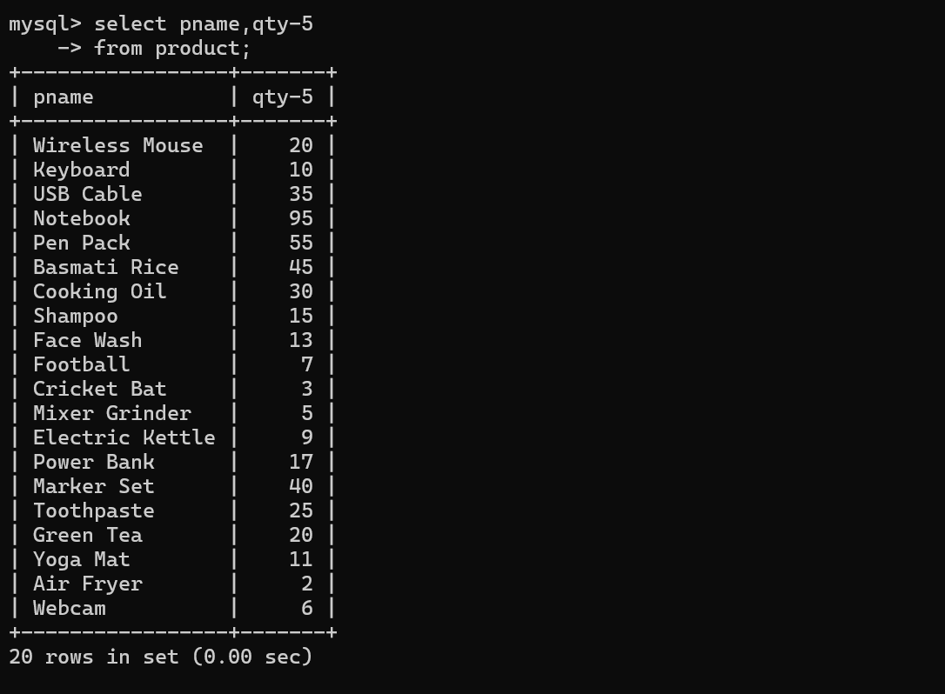

5. Display pname and a calculated column showing double the current quantity.
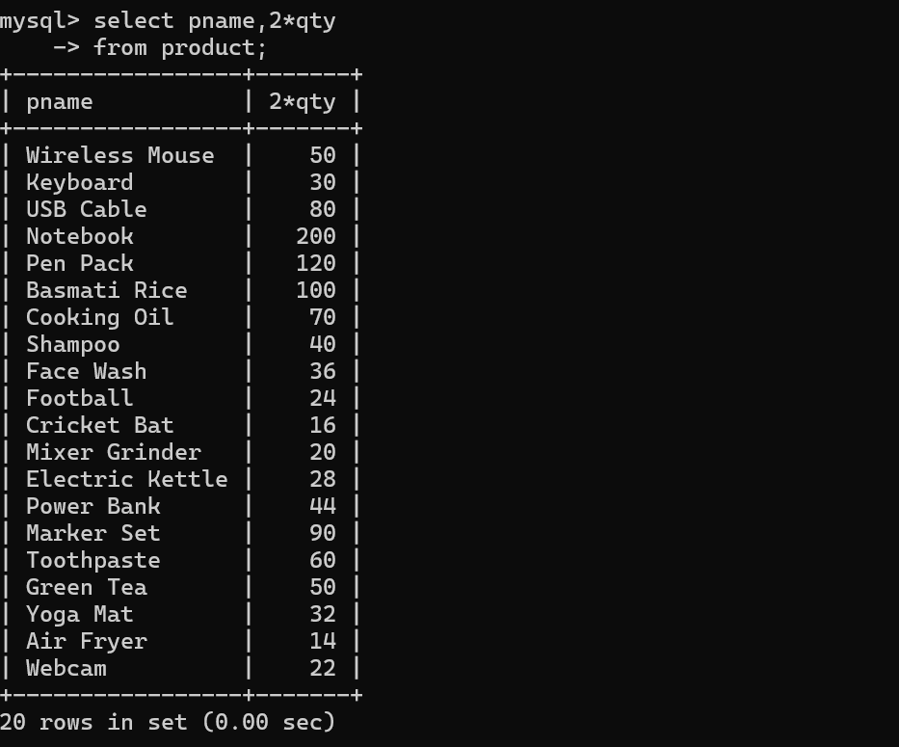

6. Display pname and a calculated column showing half of the current quantity.
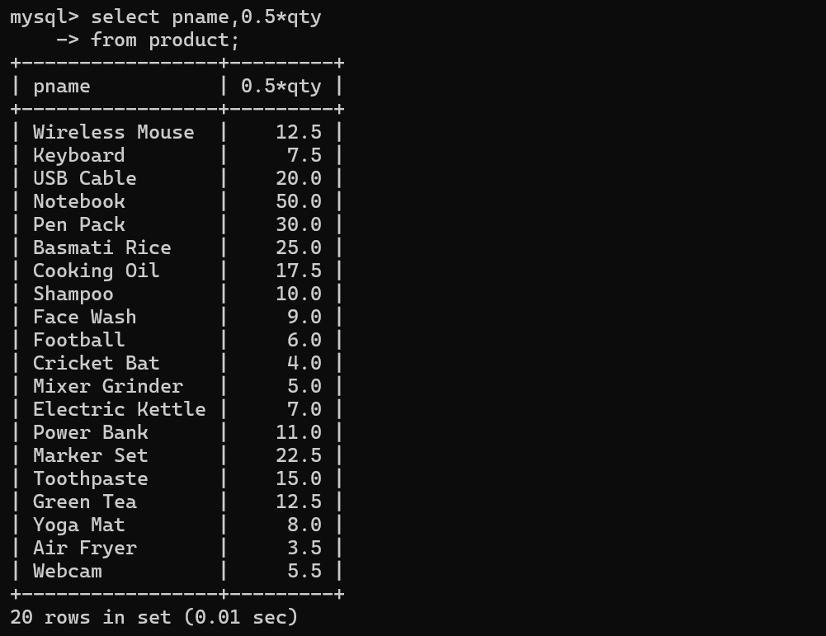

7. Display pid, pname and qty for products whose quantity is between 10 and 30.
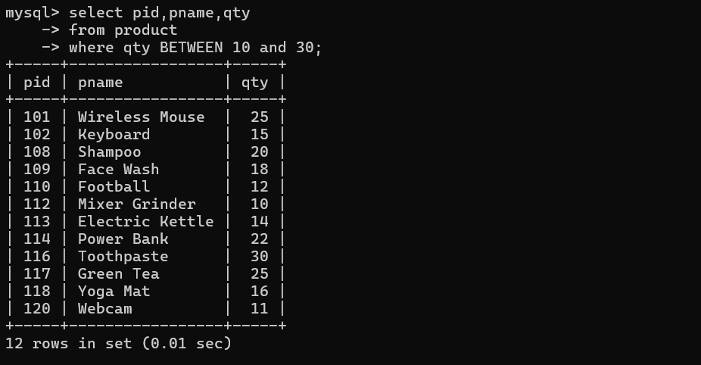
8. Display all products whose quantity is NOT between 10 and 30.
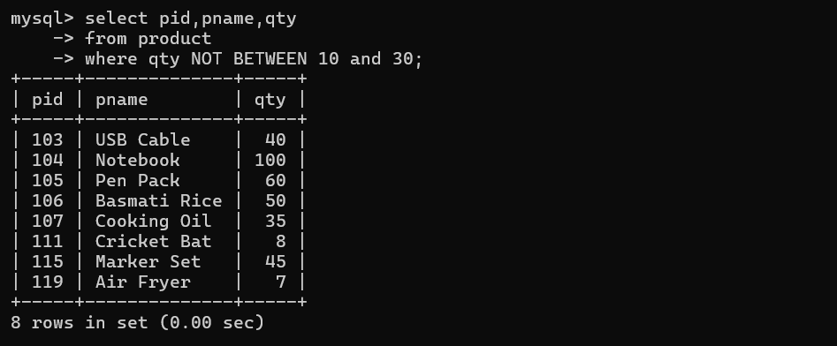
9. Display products belonging to category IDs 1, 3, or 5 using the IN
operator.
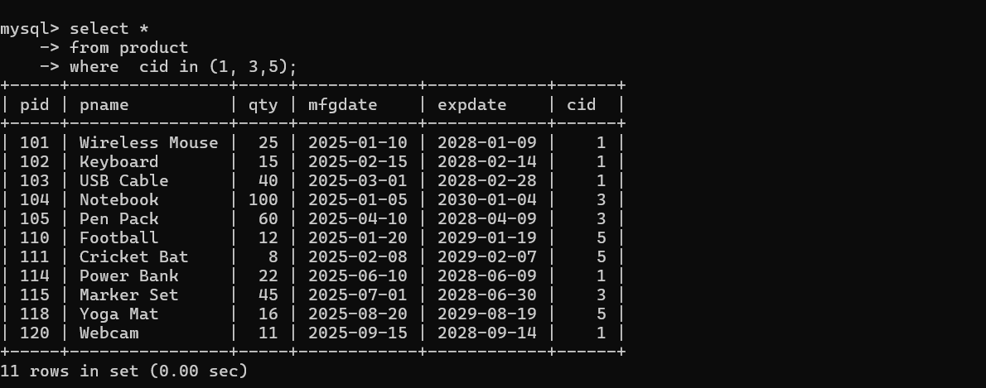
10. Display products whose category ID is NOT IN 2, 4, and 6.
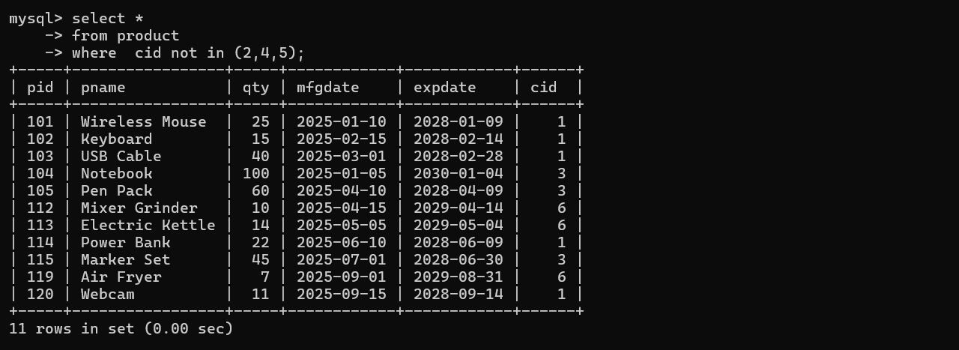
11. Display products whose quantity is greater than 20 AND category ID is 1.
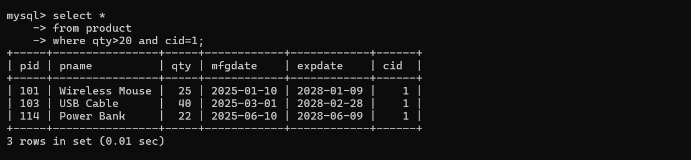

12. Display products whose quantity is less than 20 OR category ID is 5.
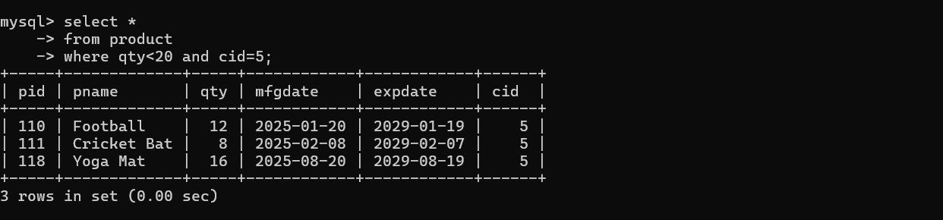
13. Display products whose quantity is between 10 and 30 AND category ID is
either 1 or 3.
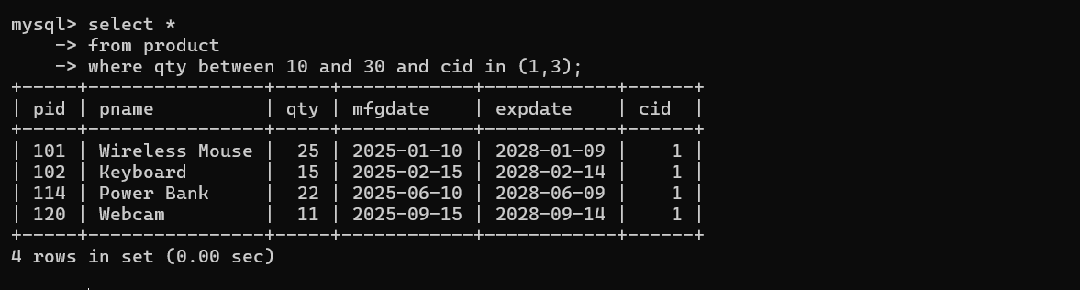

14. Display products whose quantity is greater than 40 OR quantity is less
than 10.
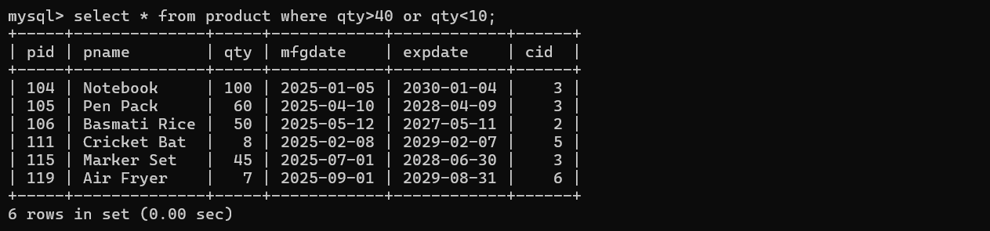
15. Display products whose quantity is greater than 15 AND quantity is less
than 50 AND category ID is 1.
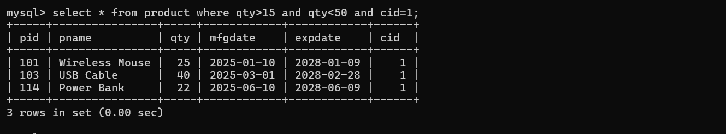
16. Display products manufactured between '2025-02-01' and '2025-06-30'
using the BETWEEN operator.
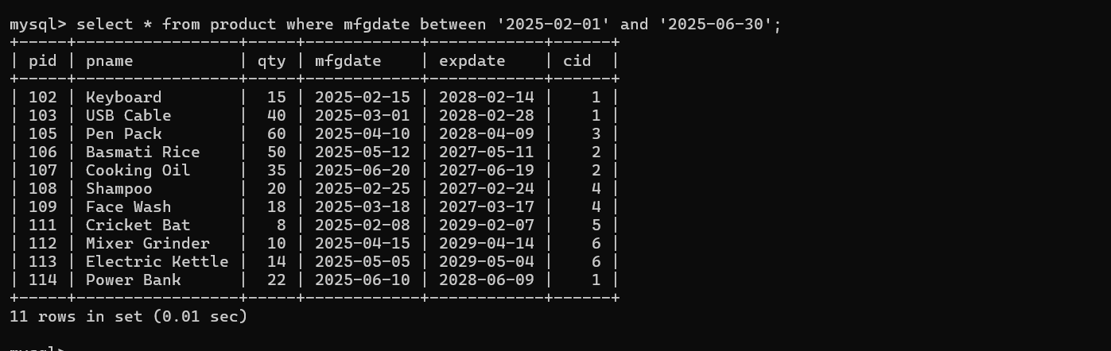
17. Display products whose expiry date is NOT between '2027-01-01' and
'2028-12-31'.
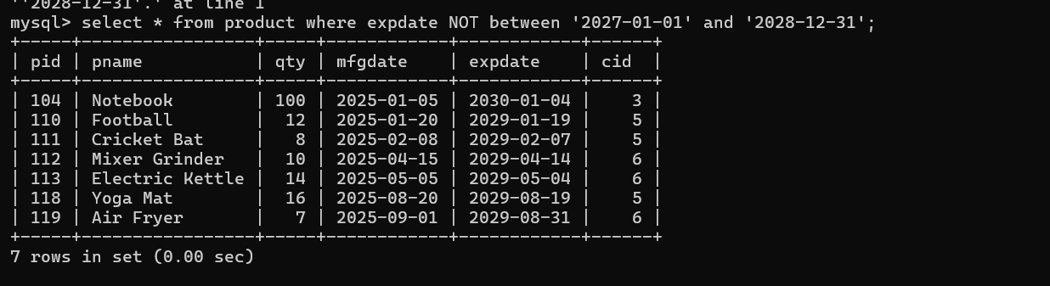

18. Display products whose quantity, when divided by 5, has remainder 0.
Use the modulo (%) operator.
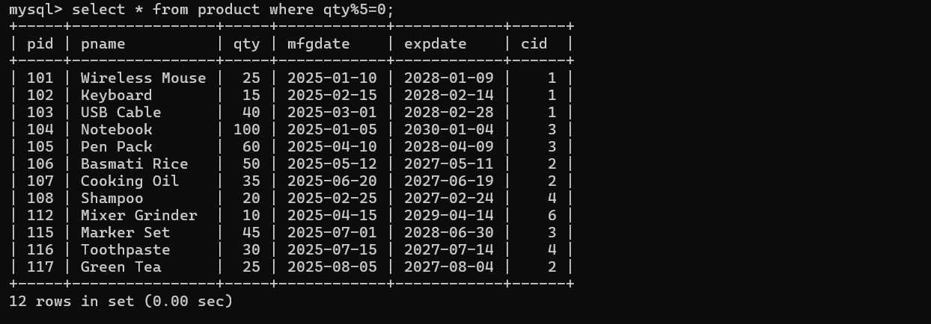
19. Display products whose quantity is greater than 20 AND whose category ID
is NOT 2.
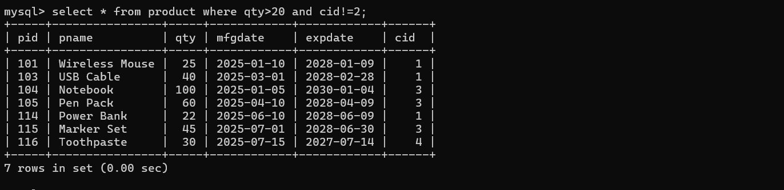
20. Display products where either:
- quantity is between 10 and 20 AND category ID is 1,
OR
- quantity is between 30 and 50 AND category ID is 2.
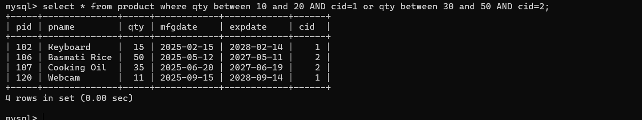

Day(3)
Date and Time functions
- Write a query to display the first day of the month (in datetime format) three months before the current month.
Sample current date : 2014-09-03
Expected result : 2014-06-01
SELECT DATE_FORMAT(DATE_SUB('2014-09-03', INTERVAL 3 MONTH), '%Y-%m-01');
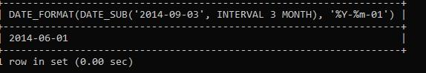
- Write a query to display the last day of the month (in datetime format) three months before the current month.
Select * from emp where last_day(date_sub(curdate(),interval 3 month));
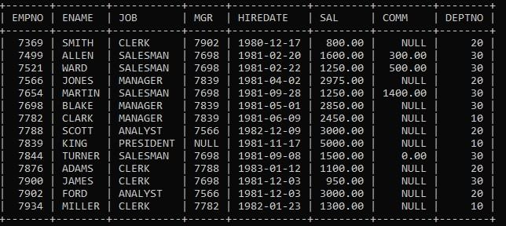
- Write a query to get the distinct Mondays from hiredate in emp tables.
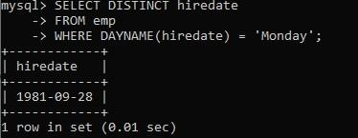
- Write a query to get the first day of the current year.
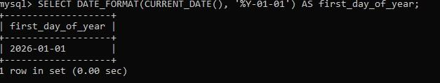
- Write a query to get the last day of the current year.
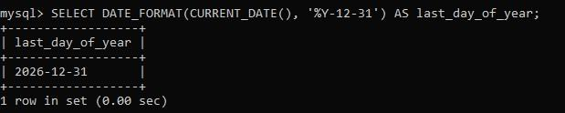
- Write a query to calculate your age in year.
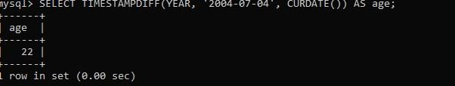
- Write a query to get the current date in the following format.
Sample date : 04-sep-2014
Output : September 4, 2014
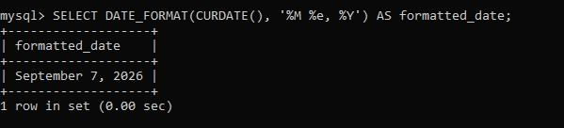

- Write a query to get the current date in Thursday September 2014 format. Thursday September 2014
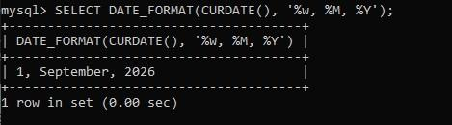
- Write a query to extract the year from the current date.
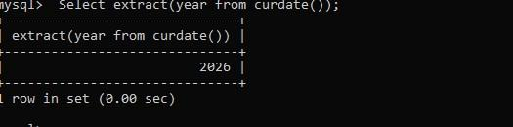
- Write a query to get the first name and hire date from employees table where hire date between '1987-06-01' and '1987-07-30'
- Write a query to display the current date in the following format.
Sample output: Thursday 4th September 2014 00:00:00
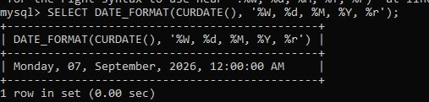
- Write a query to display the current date in the following format.
Sample output: 05/09/2014
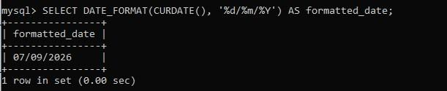
- Write a query to display the current date in the following format.
Sample output: 12:00 AM Sep 5, 2014
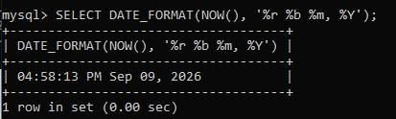
- Write a query to get the employees who joined in the month of June.
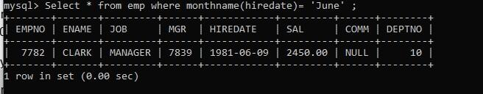

- Write a query to get the years in which more than 10 employees joined.
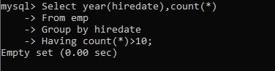
- Write a query to get first name of employees who joined in 1987. Select ename from emp where hiredate between ’1987-01-01’ and1987-12-31’;
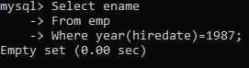
- Write a query to get employees whose experience is more than 5 years.
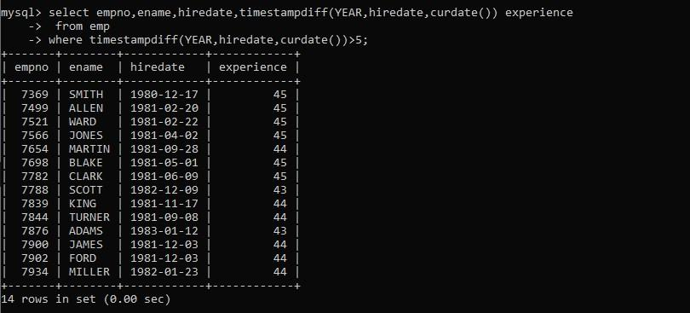
- Write a query to get employee ID, last name, and date of first salary of the employees.
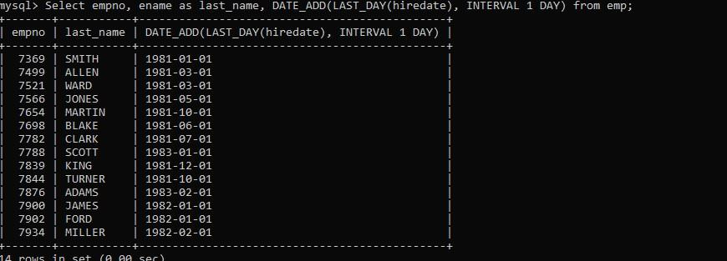
- Write a query to get first name, hire date and experience of the employees.
Sample table: employees
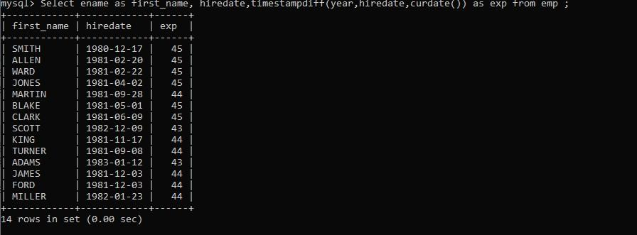

- Write a query to get the department ID, year, and number of employees joined.
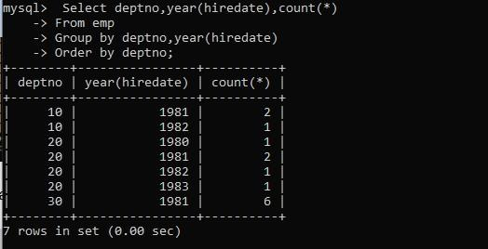

(Day 4)

Question 1 – Online Shopping System
Create the following tables:
Customer
customerid, customername, email, phone
Orders
orderid, orderdate, amount, status, customerid
A. CREATE TABLE
1. Create Customer with customerid as the PRIMARY KEY.
2. customername should be NOT NULL.
3. email should be NOT NULL and UNIQUE.
4. phone should be UNIQUE.
5. Create Orders with orderid as the PRIMARY KEY.
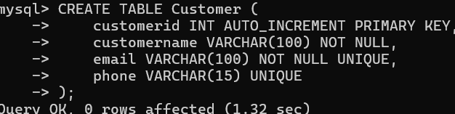
6. orderdate should be NOT NULL.
7. Set the default value of amount to 0.
8. Set the default value of status to 'Pending'.
9. customerid should be a FOREIGN KEY referencing Customer(customerid).
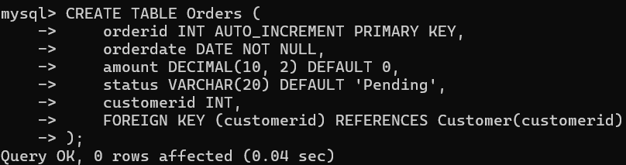
B. ALTER TABLE
10. Add a new column city to the Customer table.
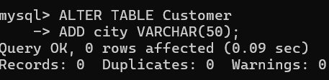
11. Add a new column shippingaddress to the Orders table.
12. Add a NOT NULL constraint to shippingaddress.
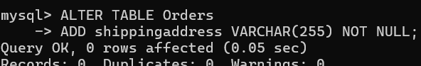
13. Add a new column paymentmode to the Orders table.
14. Set the default value of paymentmode to 'Cash'.
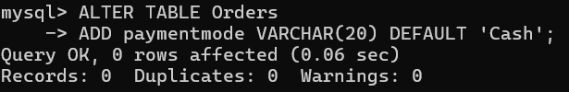
15. Rename the phone column of Customer to mobileno if your database supports column renaming.
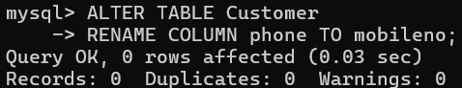
C. INSERT
16. Insert 5 customers into the Customer table.
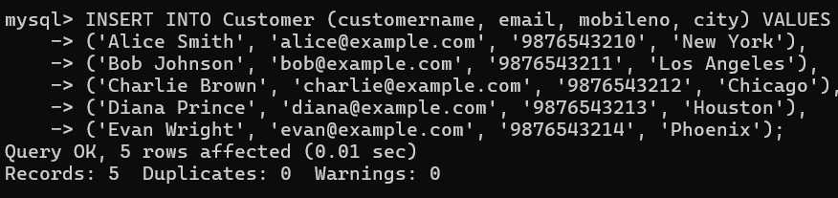
17. Insert 7 orders into the Orders table.
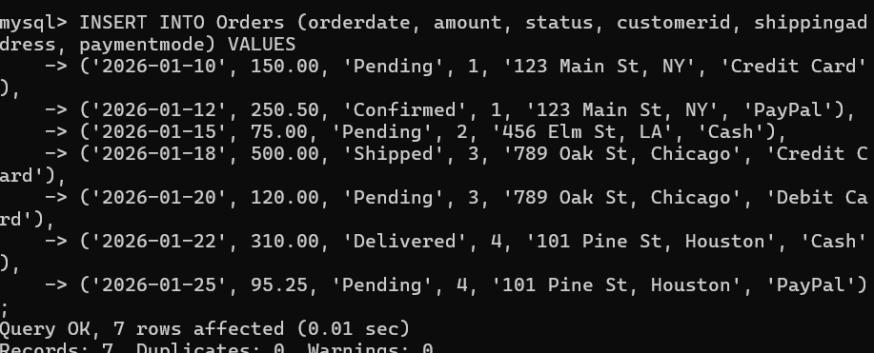
18. Insert one order without specifying status and verify that the default value is inserted.
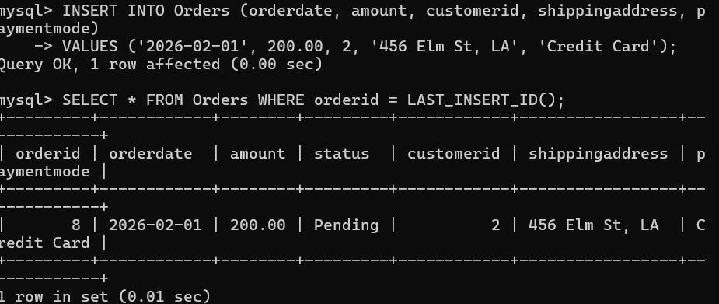
19. Insert one order without specifying amount and verify the default value.
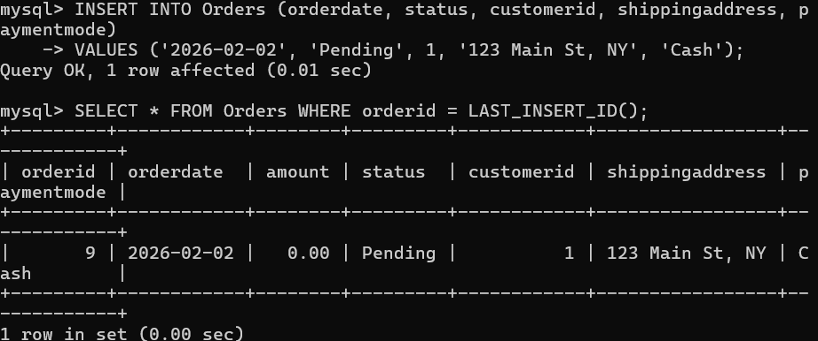
D. UPDATE
20. Update the city of a particular customer.
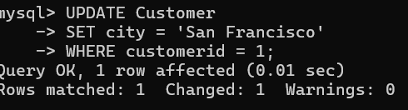
21. Increase the amount of a particular order.
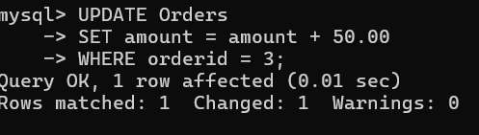
22. Change the status of an order from 'Pending' to 'Confirmed'. 23. Change the payment mode of a particular order.
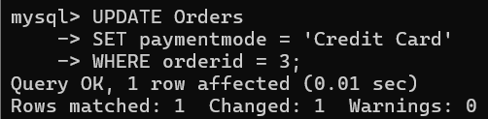
E. DELETE
24. Delete a particular order.
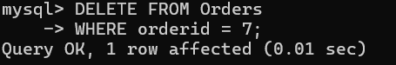
25. Delete a customer who does not have any orders.
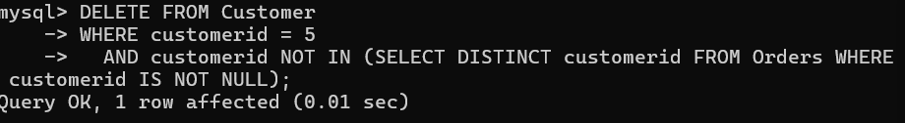
26. Try deleting a customer who has orders and observe the result because of the FOREIGN KEY constraint.
Question 2 – Movie Ticket Booking System Create the following tables:
Movie
movieid, moviename, language, duration
Booking
bookingid, customername, ticketcount, bookingdate, movieid
A. CREATE TABLE
1. Create Movie with movieid as the PRIMARY KEY.
2. moviename should be NOT NULL and UNIQUE.
3. language should be NOT NULL.
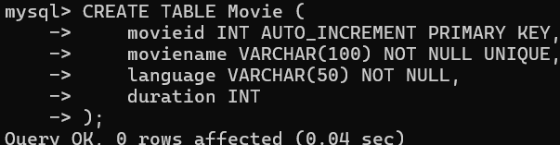
4. Create Booking with bookingid as the PRIMARY KEY.
5. customername should be NOT NULL.
6. Set the default value of ticketcount to 1.
7. bookingdate should be NOT NULL.
8. movieid should be a FOREIGN KEY referencing Movie(movieid).
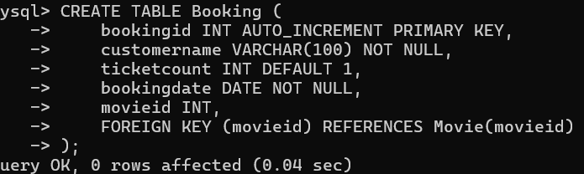
B. ALTER TABLE
9. Add price to the Booking table.
10. Set the default value of price to 200.
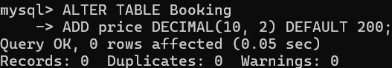
11. Add theatre to the Booking table.
12. Add a NOT NULL constraint to theatre.
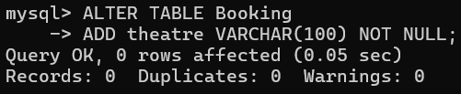
13. Add genre to the Movie table.
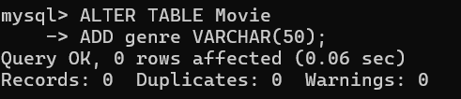
14. Add a UNIQUE constraint on theatre only if appropriate for your design. Explain why it may or may not be suitable.
C. INSERT
15. Insert 5 movies.
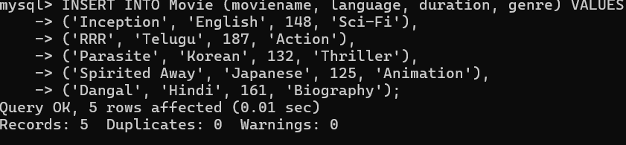
16. Insert 8 bookings.
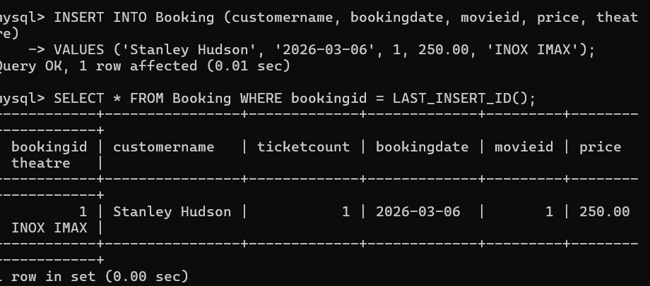
17. Insert a booking without specifying ticketcount and verify the default value. 18. Insert a booking without specifying price and verify the default value.
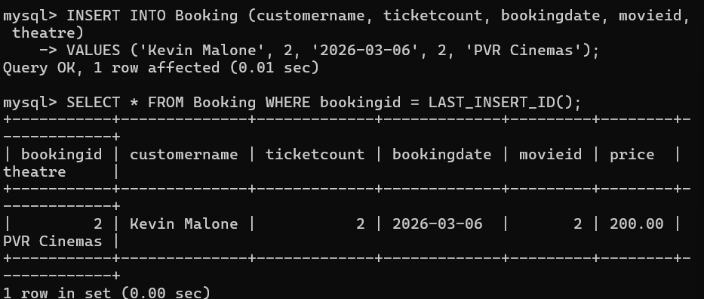
D. UPDATE
19. Change the language of a movie.
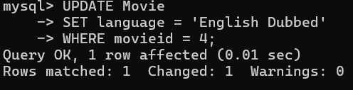
20. Update the duration of a movie.
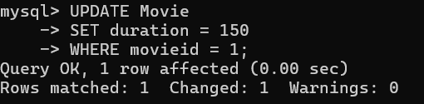
21. Change the number of tickets for a particular booking.
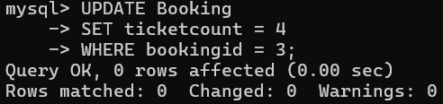
22. Change the price of a booking.
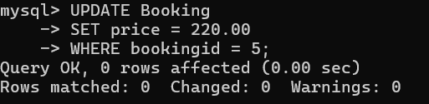
23. Change the theatre of a booking.
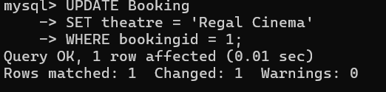
E. DELETE
24. Delete a particular booking.
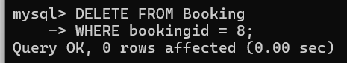
25. Delete a movie that has no bookings.
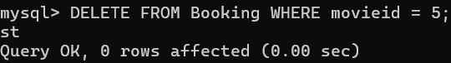
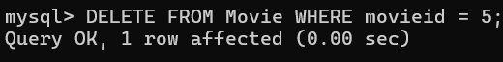
26. Try deleting a movie that is referenced by a booking and observe the result.
Question 3 – Vehicle Service Center Create the following tables:
Vehicle
vehicleid, vehicleno, model, ownername, phone
Service
serviceid, servicedate, servicetype, charges,vehicleid A. CREATE TABLE
1. Create Vehicle with vehicleid as the PRIMARY KEY.
2. vehicleno should be NOT NULL and UNIQUE.
3. ownername should be NOT NULL.
4. phone should be UNIQUE.
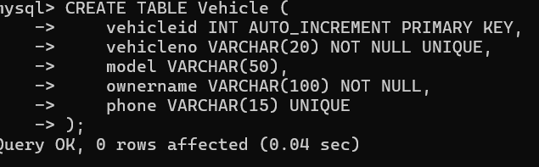
5. Create Service with serviceid as the PRIMARY KEY.
6. servicedate and servicetype should be NOT NULL.
7. Set the default value of charges to 0.
8. Create a FOREIGN KEY on vehicleid referencing Vehicle(vehicleid).
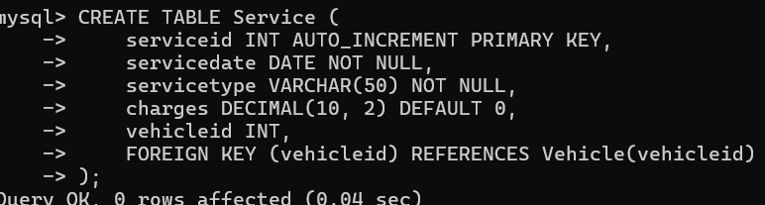

B. ALTER TABLE
9. Add color to the Vehicle table.
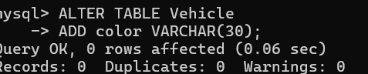
10. Add address to the Vehicle table.
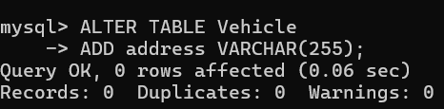
11. Add servicestatus to the Service table.
12. Set the default value of servicestatus to 'Pending'.
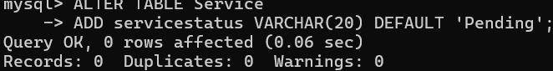
13. Add mechanicname to the Service table.
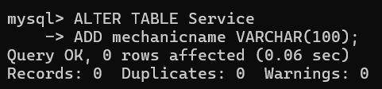
14. Modify the size of ownername to allow longer names.
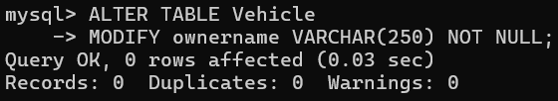
15. Add a UNIQUE constraint on phone if it was not defined while creating the table.
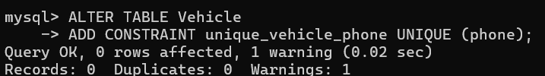
C. INSERT
16. Insert 5 vehicles.
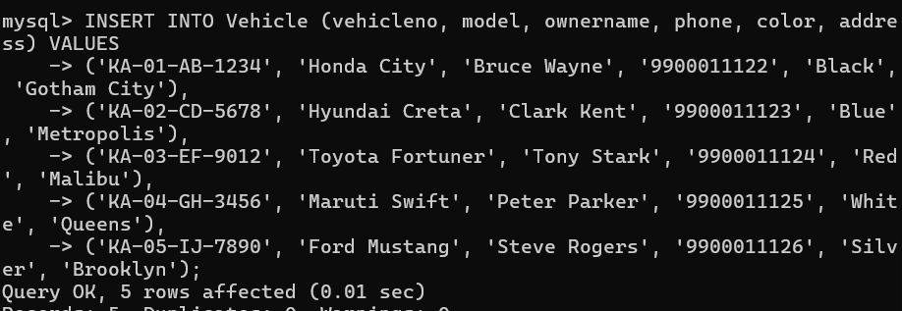
17. Insert 8 service records.
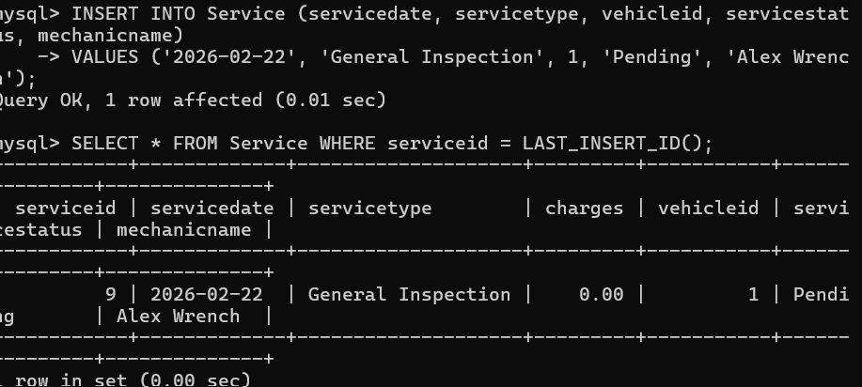
18. Insert a service record without specifying charges and verify the default value.
19. Insert a service record without specifying servicestatus and verify the default value.
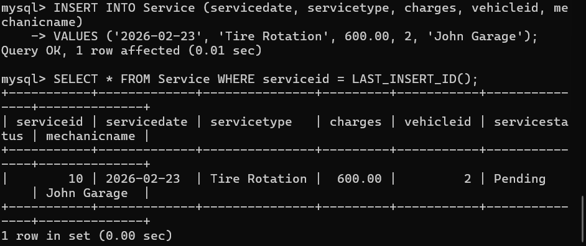
D. UPDATE
20. Change the color of a particular vehicle.
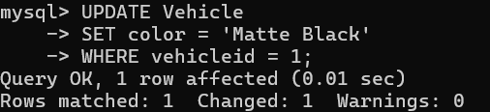
21. Change the owner's phone number.
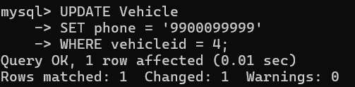
22. Increase the service charges for a particular service.
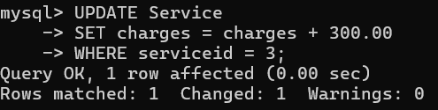
23. Change servicestatus from 'Pending' to 'Completed'.
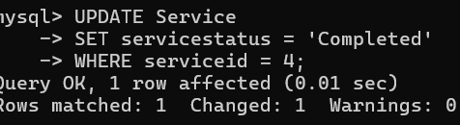
24. Change the mechanic assigned to a service.
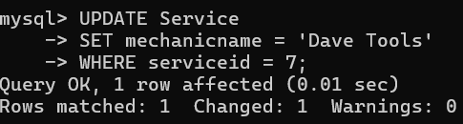
E. DELETE
25. Delete a particular service record.
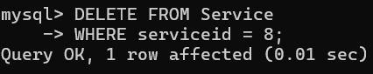
26. Delete a vehicle that has no service records.
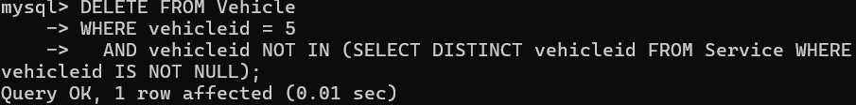
27. Try deleting a vehicle that has service records and observe the FOREIGN Keyconstraint.

(Day5)
Q1. Write SQL statement for the following

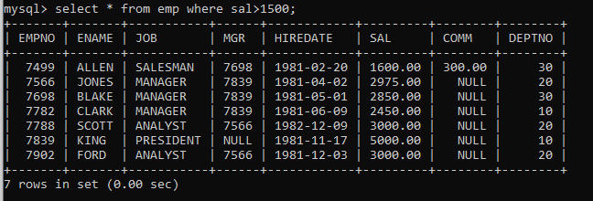
1.To find all managers with salary >1500

2. list all employees with sal >1200 and < 2000
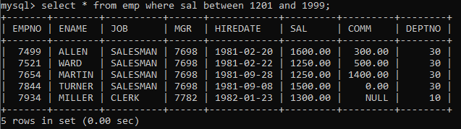

3. list all employees with sal is 1600 or sal is 800 or sal is 1900
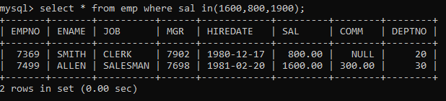

4. list all employees with ‘R’ at second last position in name
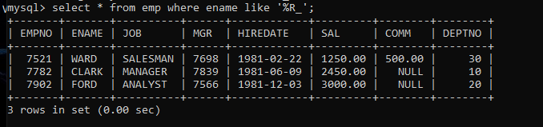

5. List all employees with name starts with A and ends with N
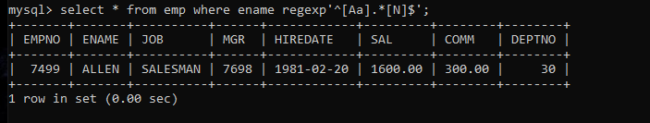

Q2. Solve following

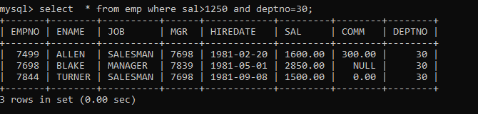
1.list all employees with salary > 1250 and dept no=30

2. list all employees with salary >=1250 and <= 3000
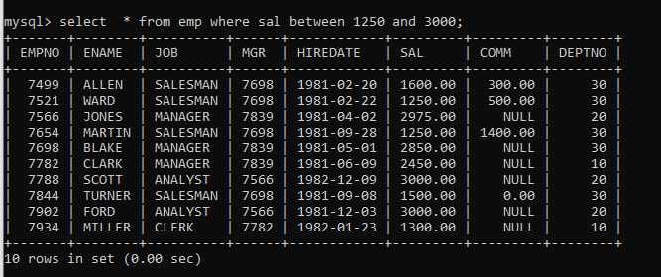

3. list all employees with salary >1250 and < 3000
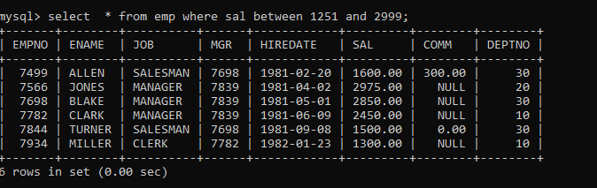

4. list all employees with salary either equal to 3000 or 1250 or 2500
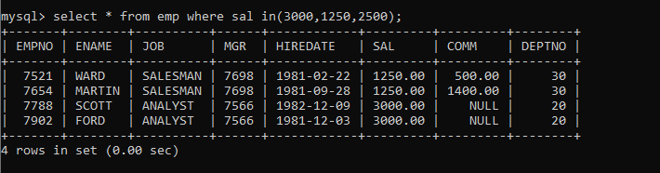

5. list all employee with name=SMITH
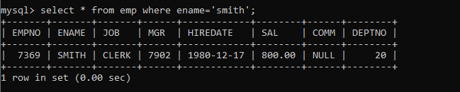

6. list all employees with name starting with S
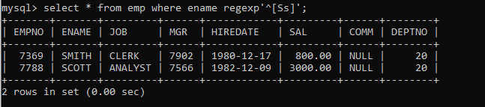

7. list all employees with name ending with S
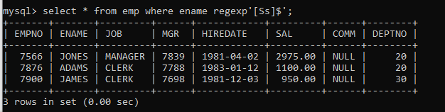

8. list all employees with name contains l at 2nd position
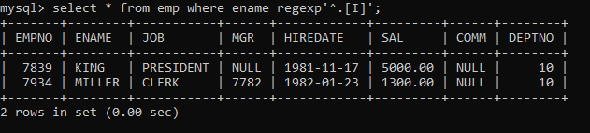
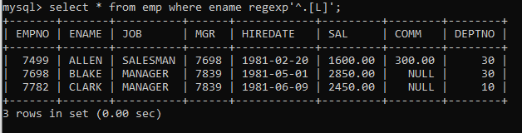

9. list all employees with name starts with A ends with N and somewhere in between L is there
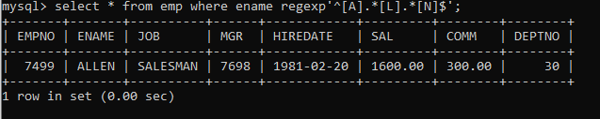

10. list all employees with name starts with A and B at 3 rd position and P at second last position
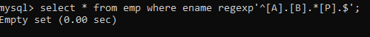

11. List all employees with name starts with either A or starts with S or starts with W
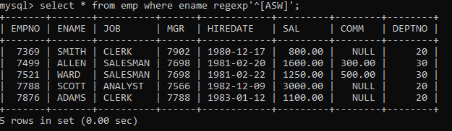

Practice Aggregate function:

12. find max sal and min sal for each job
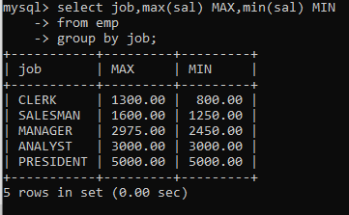

13. find how many employess have not received commission
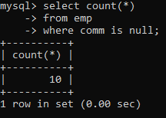

14. find sum of sal of all employees working in dept no 10
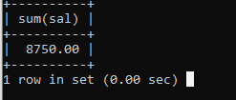

15. find maximum salary,average sal for each job in every department
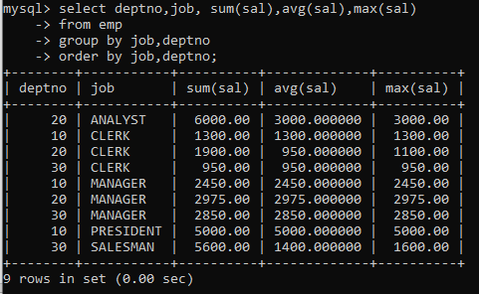

16. find max salary for every department if deptno is > 15 and arrange data in deptno order.
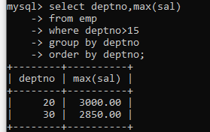

17. find sum salary for every department if sum is > 2000
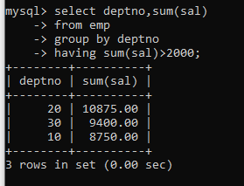

18. list all department which has minimum 5 employees
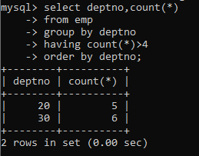

19. count how many employees earn salary more than 2000 in each job
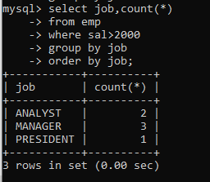

20. list all enames and jobs in small case letter

21. list all names and jobs so that the length of name should be 15 if it is smaller then add spaces to left
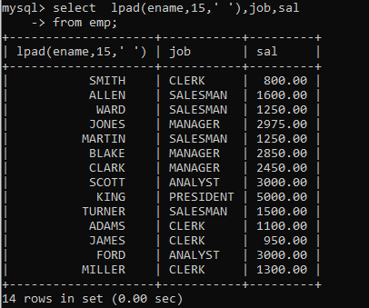

22. display min sal,max sal, average sal for all employees working under same manager
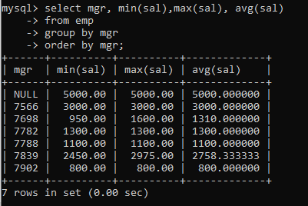

23. find sum of total earnings(sal+comm), average of sal+comm,
for all employees who earn sal > 2000 and work in either dept no 10 or 20
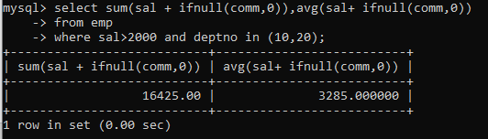

24. list all employees who joined in Aug 1980 and salary is >1500 and < 2500
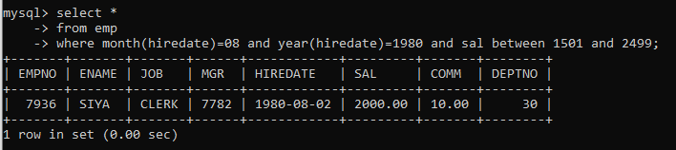

25. list all employees joined in either aug or may or dec
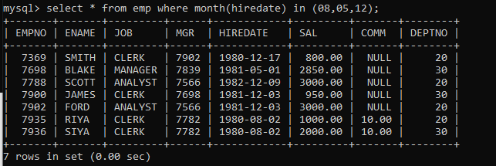

26. display name and hiredate in dd/mm/yy format for all employees whose job is clerk and they earn some commission
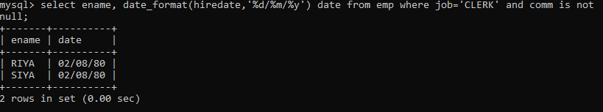

27. list empcode,empno,name and job for each employee. (note :empcode is 3 to 5 characters from name and last 2 characters of job)
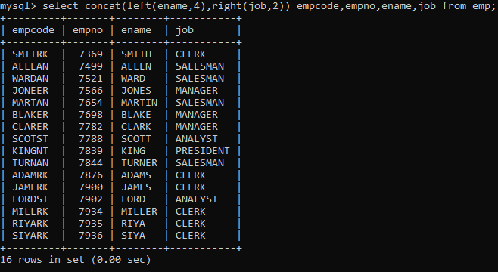
28. display thousand separator and $ symbol for sal and commission if comm is null then display it as 0, for all employees whose name starts with A and ends with N
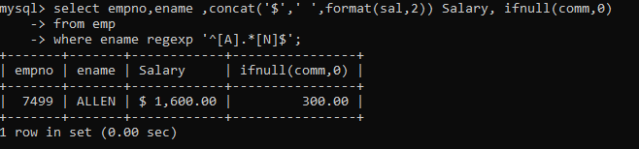

29. Display empid,name,sal,comm,remark Remark should base on following conditions
comm >= 600 "excellent Keep it up"
if it < 600 or not null "good"
otherwise "Need improvement"
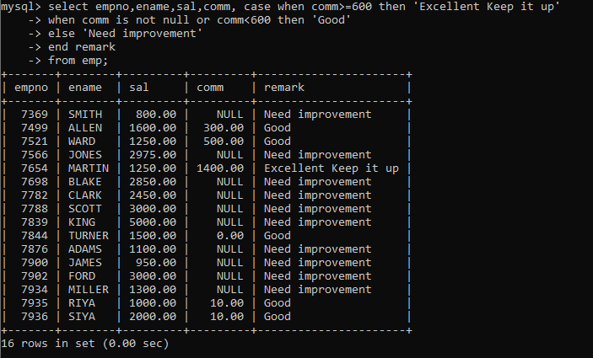

30. Display empid, name, deptno and department name by using following conditions.
dept 10 then "Hr"
if 20 then "Admin"
if 30 then "accounts"
otherwise purchase
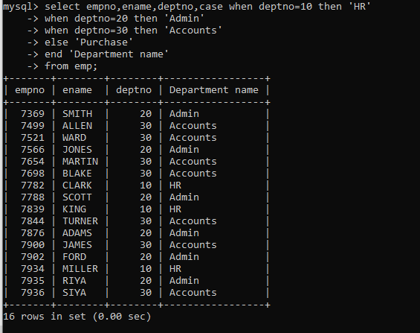
31. Practice creating following tables
a. create table mydept_DBDA and insert 5 rows into it
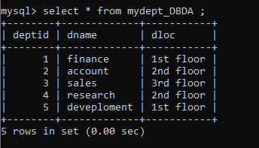
b. create myemployee table
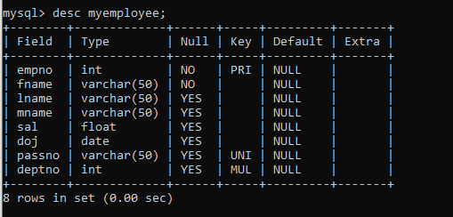

32. Create following tables Student, Course
Create table student
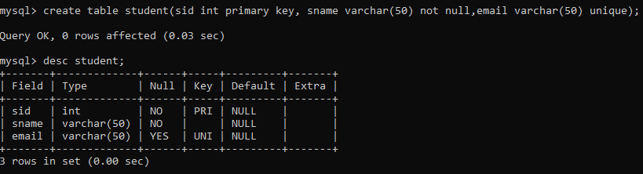
Create course table
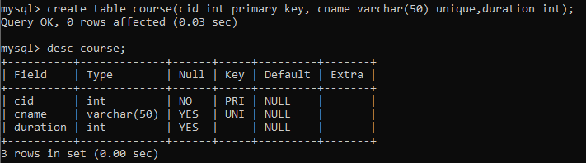

Create marks table(the table has composite primary key (studid+courseid)
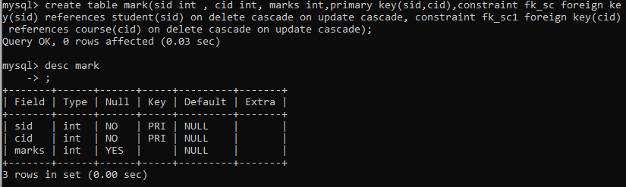
Add 5 records in each student, course and marks table
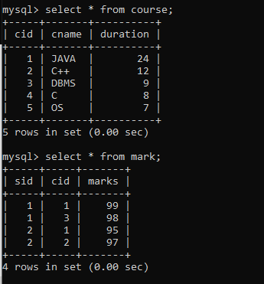
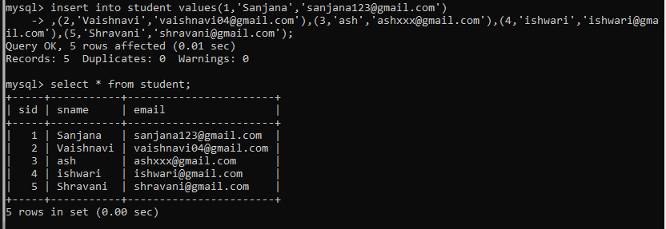

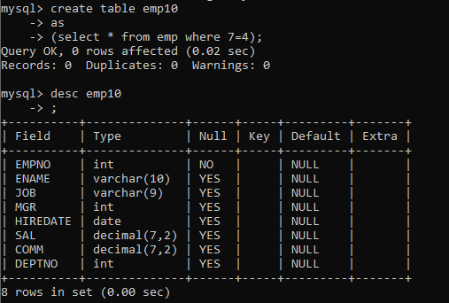
Create empty table emp10 with table structure same as emp table.

34. Solve following using alter table
a. add primary key constraint in emp table deptno column refernces ,dept table deptno
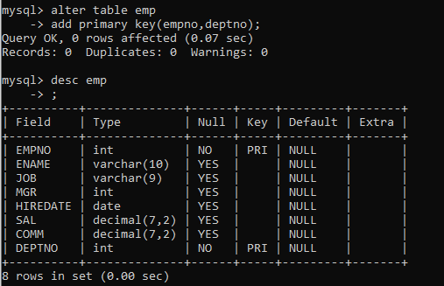

b. add new column in emp table netsal with constraint default 1000
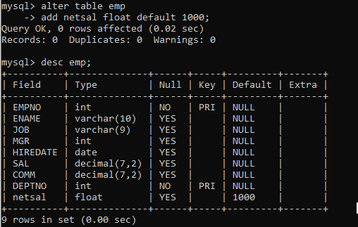
35. increase sal of each employee by 15 % sal +comm, change the job to manager and mgr to 7777 for all employees in deptno 10.
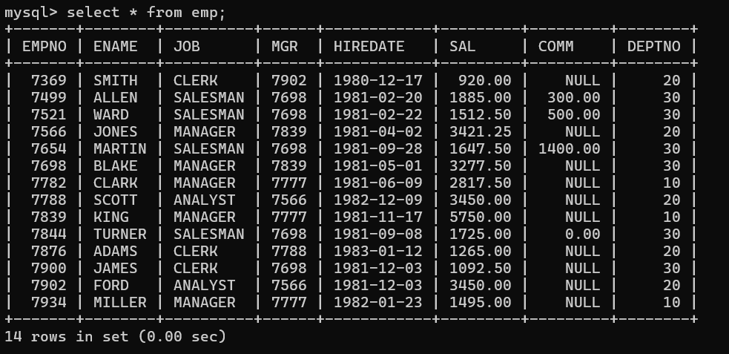

36. change job of smith to senior clerk
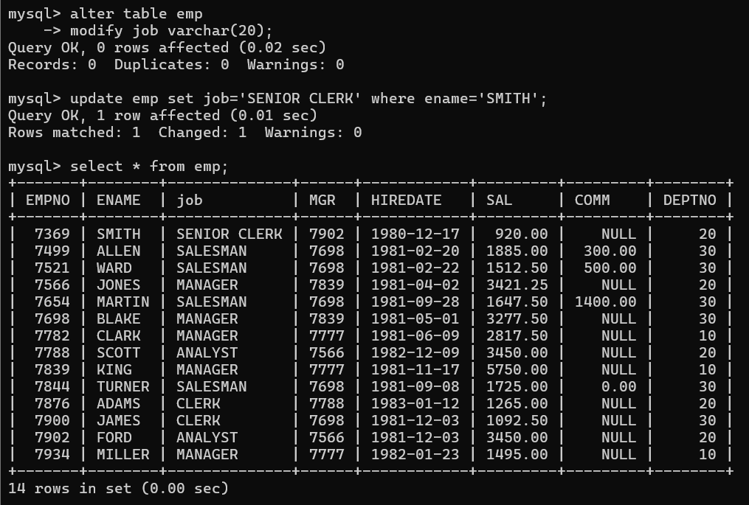
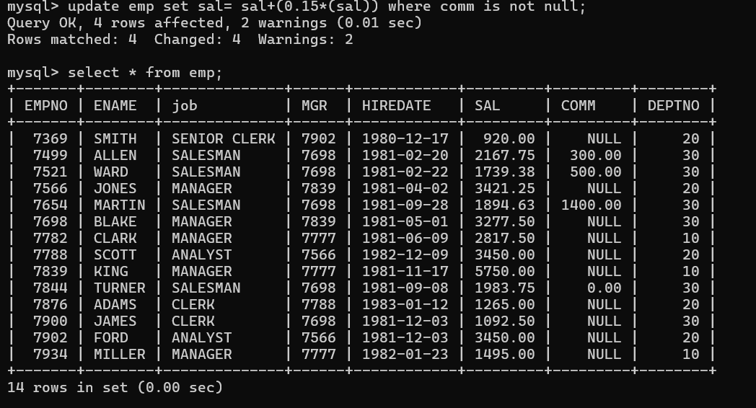
37. increase salary of all employees by 15% if they are earning some commission

38. list all employees with sal>smith's sal
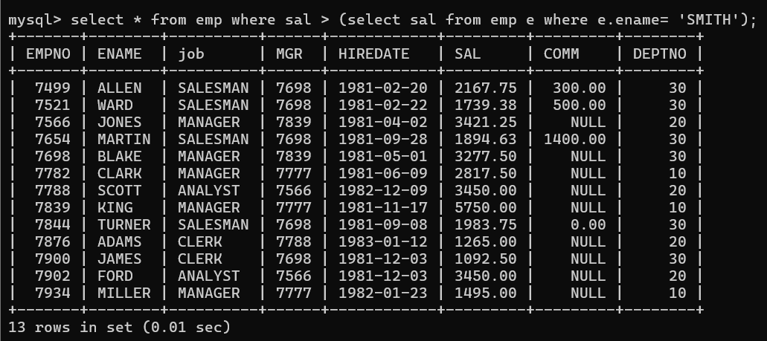
39. list all employees who are working in smith's department
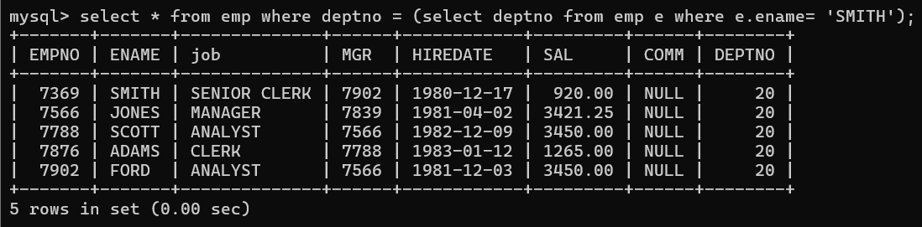
40. list all employees with sal < smith’s sal and salary > blake’s sal
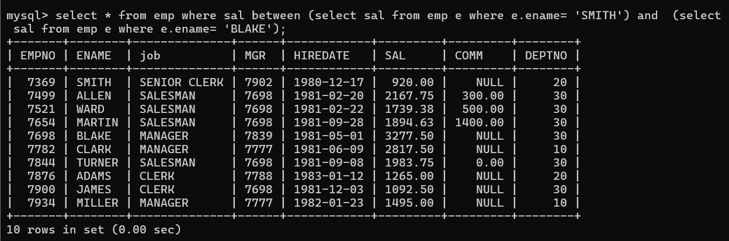

46. list all employees who earn more than average sal of Alan's department
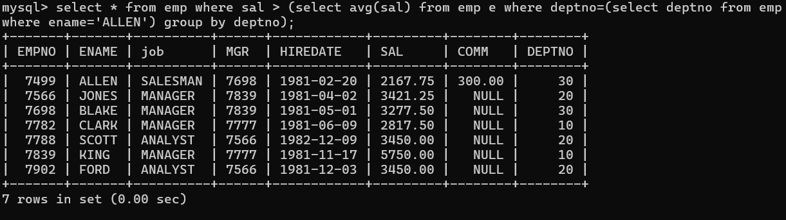
47. list all employees who are working in purchase department
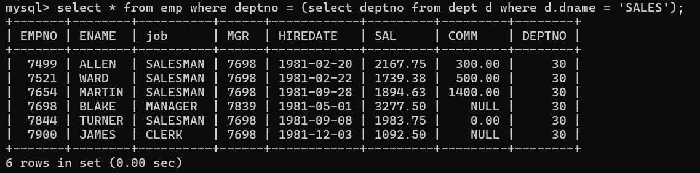
48. list all employees who earn more than average salary of their own department
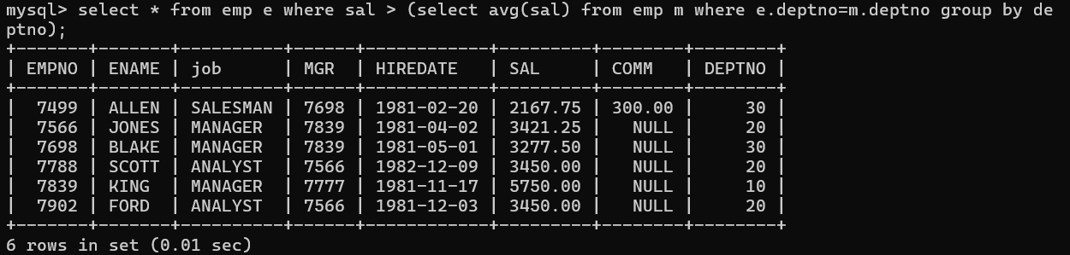
49. list all employees who earn sal > than their managers salary
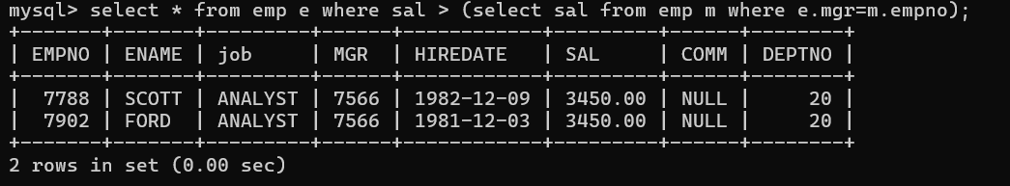

50. list all employees who are earning more than average salary of their job
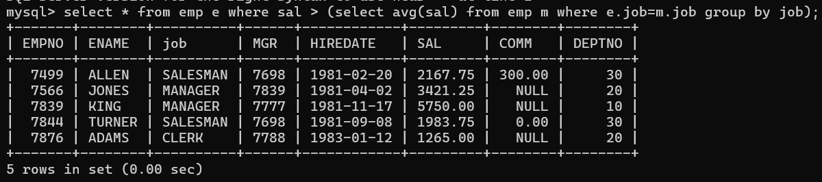

51. display employee name and department name
52. display empno,name,department name and grade (use emp,dept and salgrade table)
53. list all employees number,name, mgrno and manager name
54. create following tables and solve following questions(primary keys are marked in yellow)
foreign keys are marked in green
product(pid,pname,price,qty,cid,sid)
salesman (sid,sname,address)
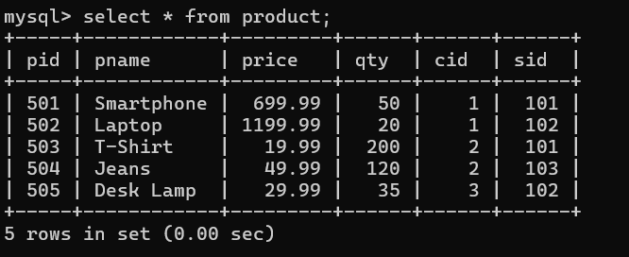
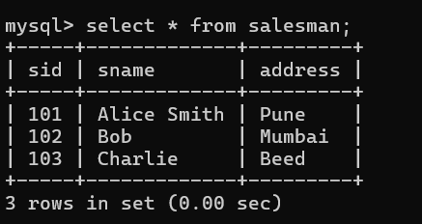
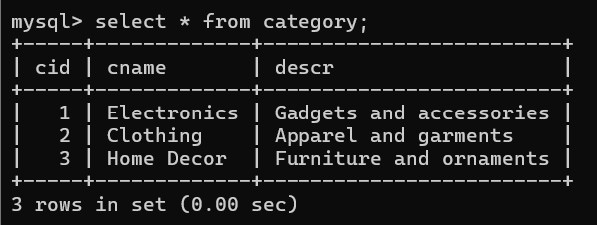
category(cid,cnam,descritpion)

1. list all product name,their category name and name of a person, who sold that product
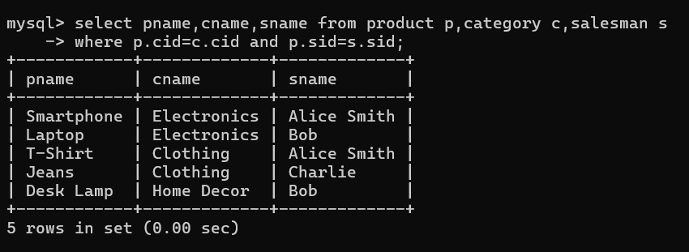
2. list all product name and salesman name for all salesman who stays in pune
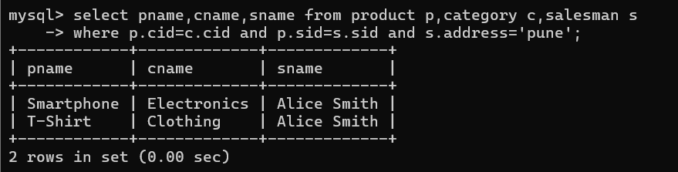
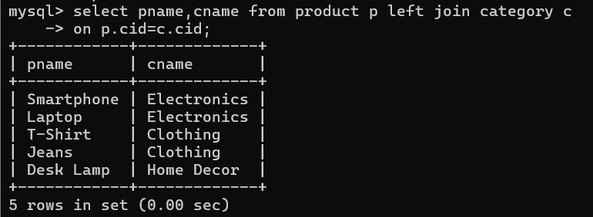
3. list all product name and category name
55.create following tables and solve following questions(primary keys are marked in yellow)
foreign keys are marked in green
faculty(fid,fname,sp.skill1,sp.skill2)
courses(cid,cname,rid,fid)
room(roomid,rname,rloc)
1. list all courses for which no room is assigned and all rooms for which are
Available
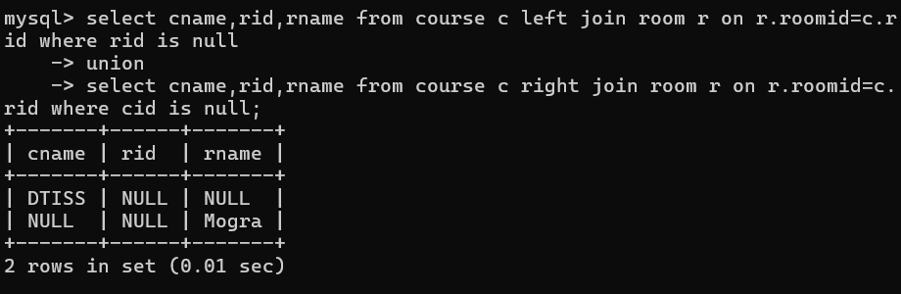
2. list all faculties who are not allocated to any course and rooms which are not
allocated to any course
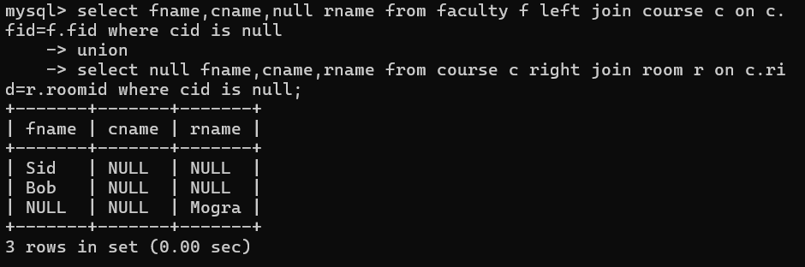
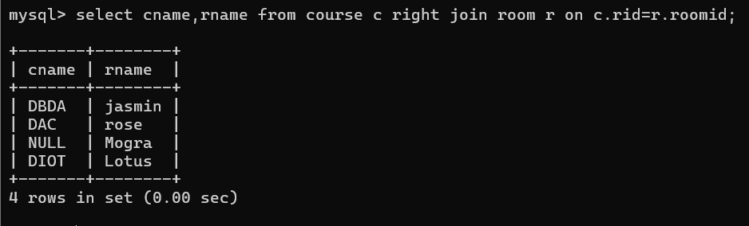
3. list all rooms which are allocated or not allocated to any courses
4. list all rooms which are not allocated to any courses
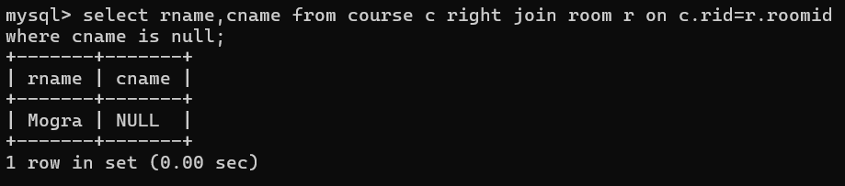
5. display courses and faculty assigned to those courses whose special skill is
database
6. display course id, course name , faculty name and special courses and room
name and room location
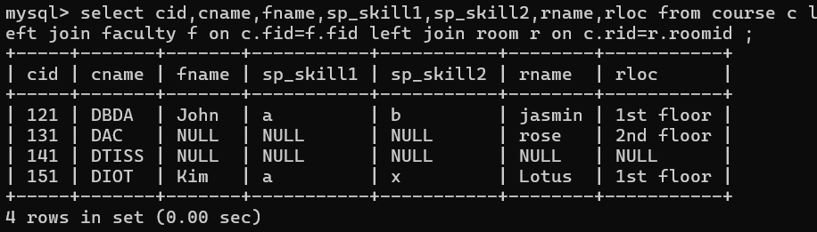

(Day 6)
location
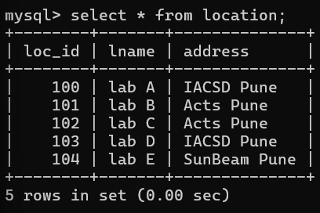
Server
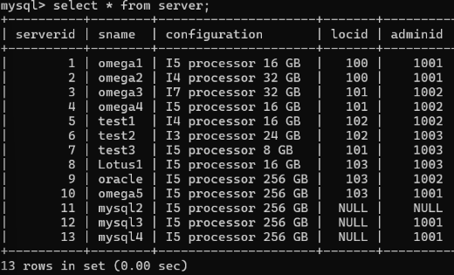

admin
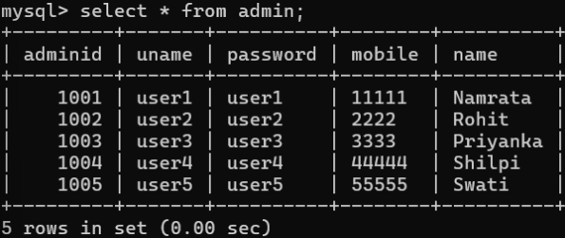
1. display all server-name, location name of the server
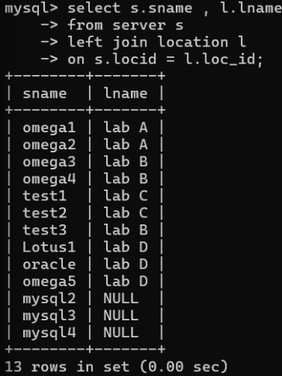
2. display all server-name, admin-name, admin mobile
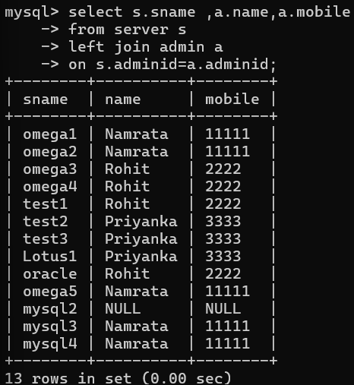
3. display all server which are managed by admin rohit
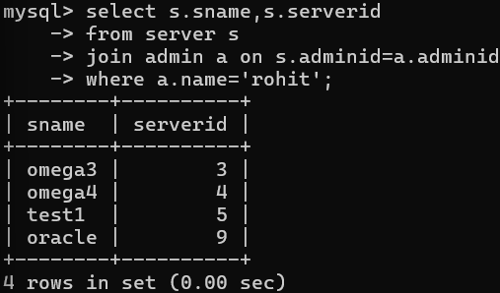

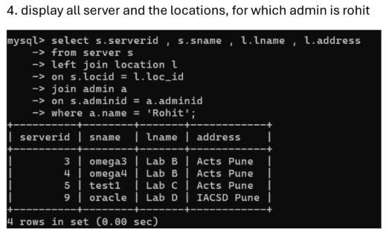
5. display all admins, for whom no server is assigned
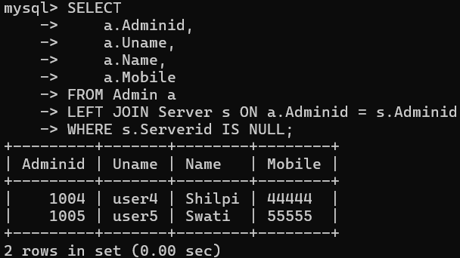
6. display all servers and admin details, and also display admins for whom no server is assigned
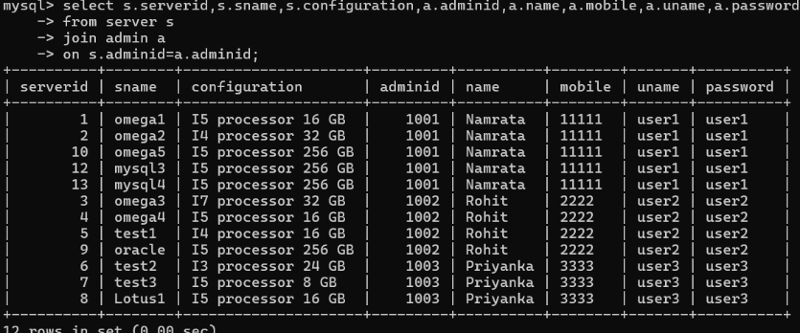
7. display servers, admins and location of the server
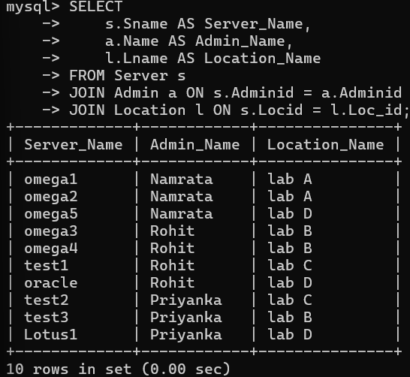
8. to display all admins for whom no server is assigned also display locations at which no server is placed
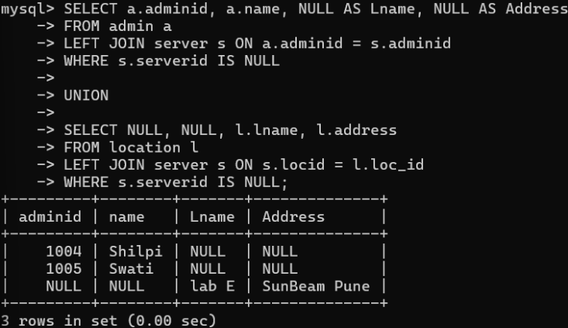
9. display all servers for which no location is assigned
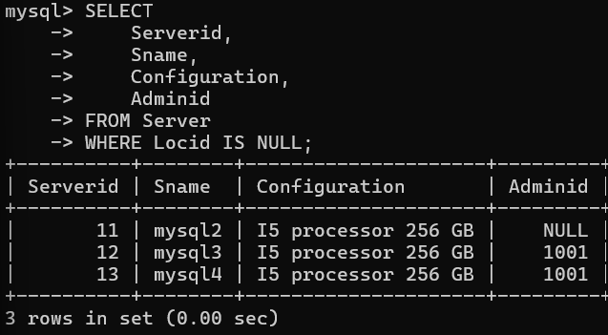
10. display all servers, for which no location is assigned,
whose admin is namrata
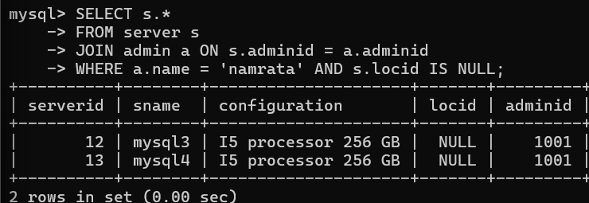

(Day 7)
SQL Window Functions
Design following tables and solve questions using window functions
• demand2 → day, qty
• demand → product, day, qty
• Sales data → product, location, sales, refunds
Demand2 table
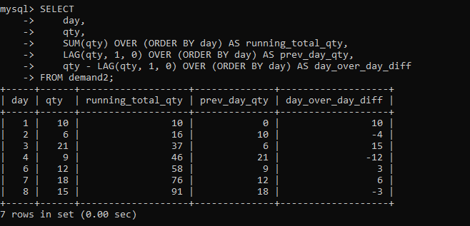

Demand table
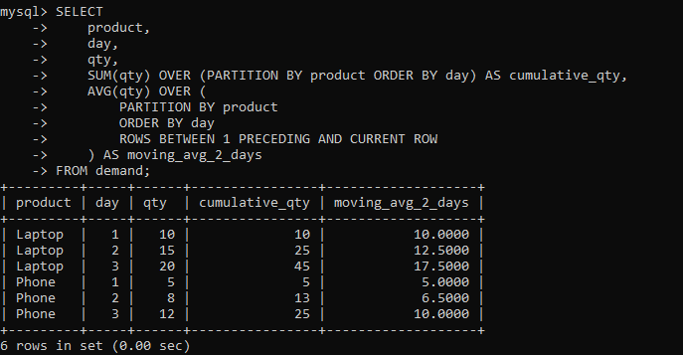

Sales data
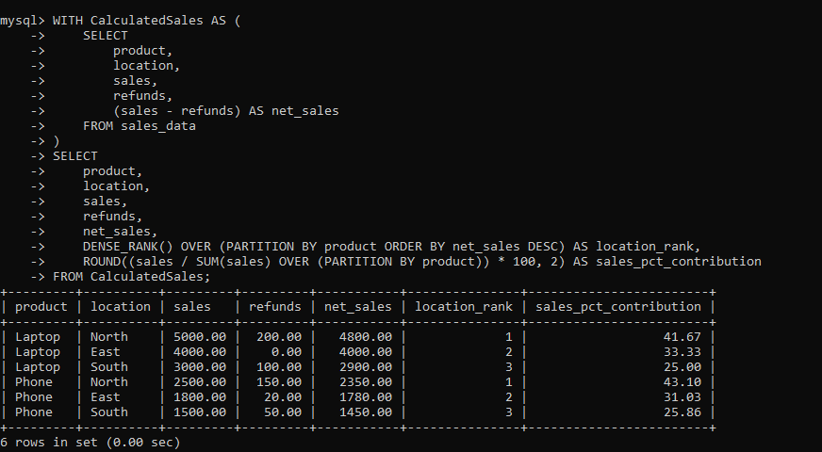

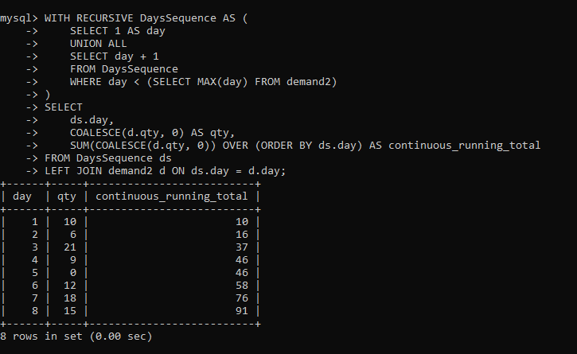
SQL Window Functions – Questions
1. Write a query to display the day and qty from the demand2 table along with the previous day's quantity using a window function.
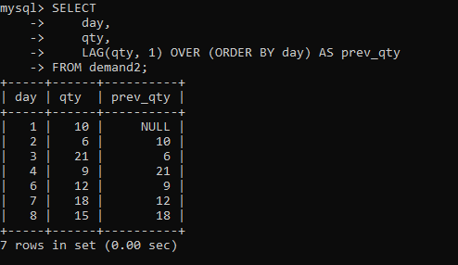
2. Write a query to display the day, qty, and the next day's quantity using a window function.
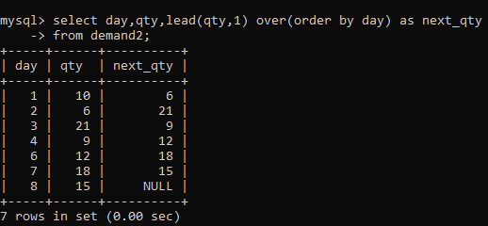
3. Write a query to display the day, qty, and the difference between the current day's quantity and the previous day's quantity.
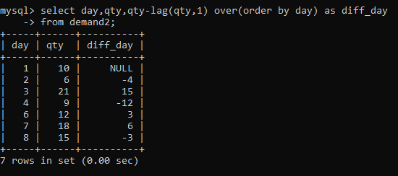
4. Write a query to display the product, day, qty, and the previous day's quantity for each product using a window function.
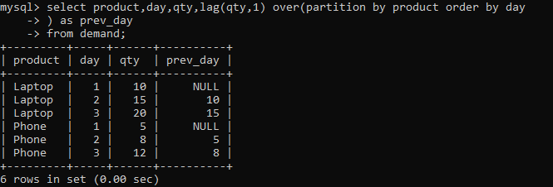
5. Write a query to display the product, day, qty, and the next day's quantity for each product.
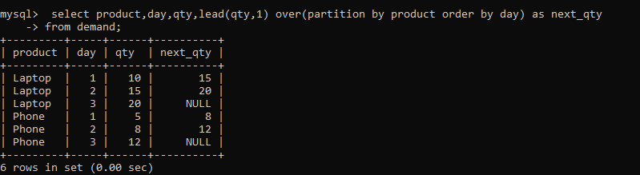
6. Write a query to display the product, day, qty, and the difference between the current day's quantity and the previous day's quantity for each product.
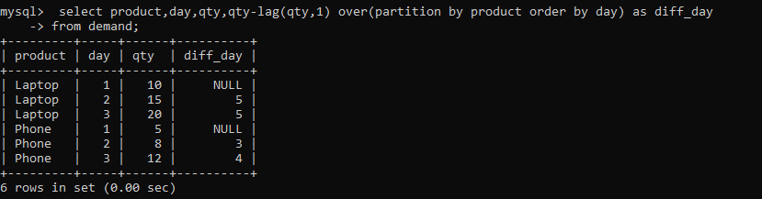
7. Write a query to display the day, qty, and the cumulative sum of quantity using a window function
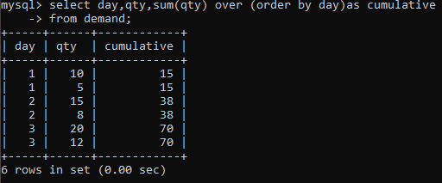
8. Using the sales_data table, write a query to display product, location, sales, refunds, and net sales (sales - refunds).
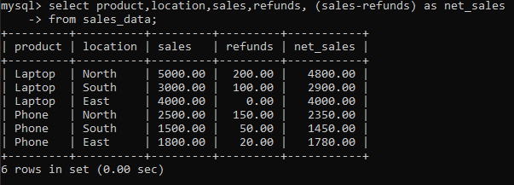
9. Write a query to rank the products based on sales within each location using a window function.
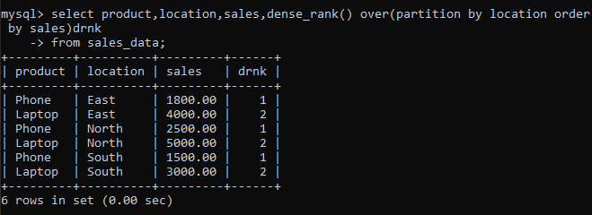
10. Write a query to calculate the total sales from the top 3 best-selling products in each location.
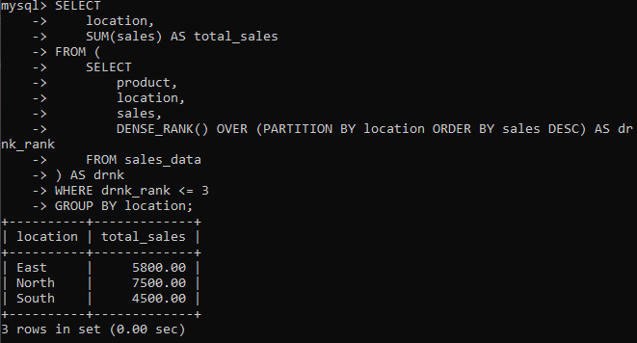
11. Write a query to display each product's sales along with the total sales of its location using a window function.
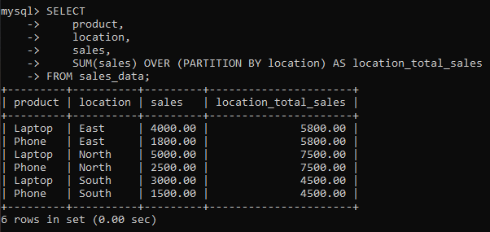

12. Write a query to display each product's sales along with the percentage contribution of that product to the total sales of its location.
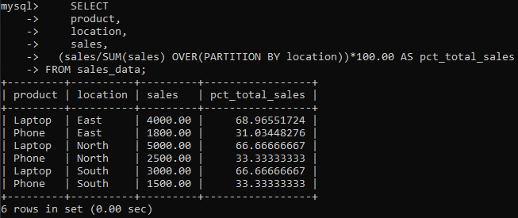
13. Write a query to display the running total of sales for each location using a window function.
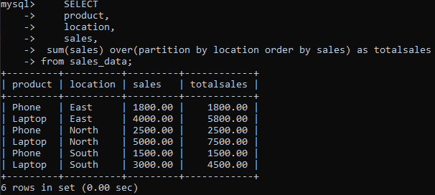
14. Write a query to display each product's sales along with the previous product's sales within the same location.

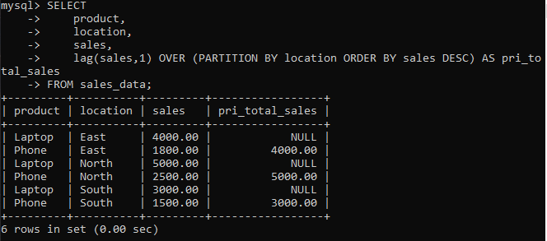
15. Write a query to display each product's sales along with the difference between its sales and the previous product's sales within the same location.
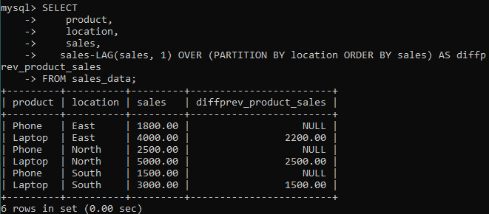

(Day 8)
Question 1. (Procedures, Functions)

1.a
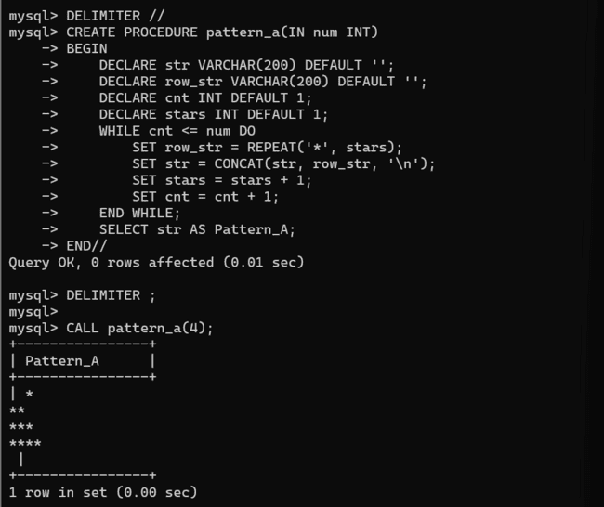
1.b

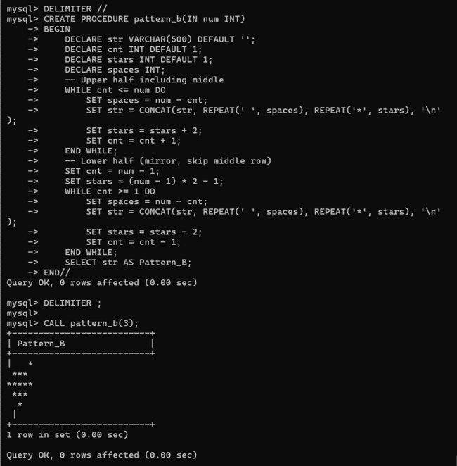
1.c
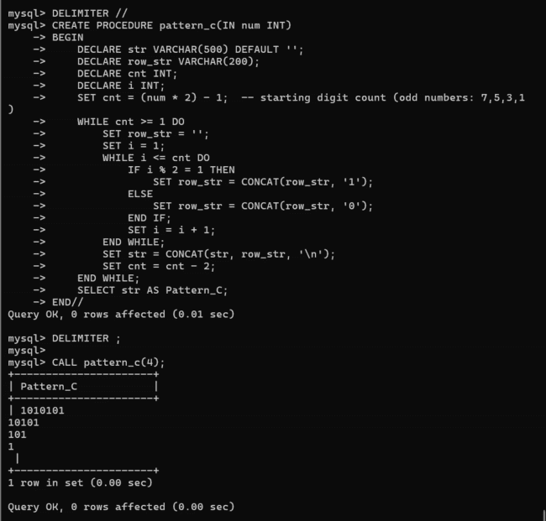
1.d
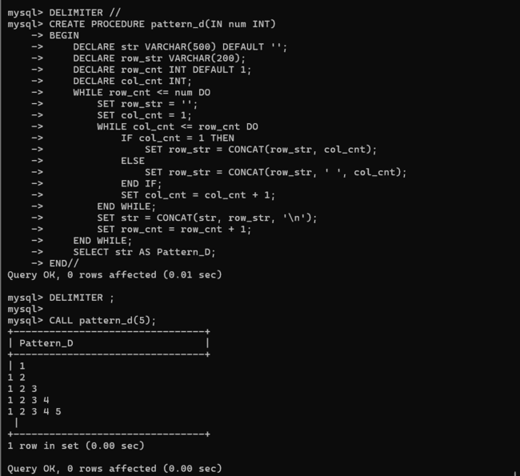
2.
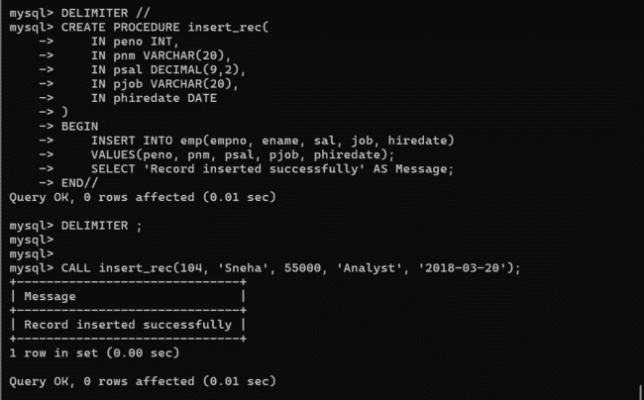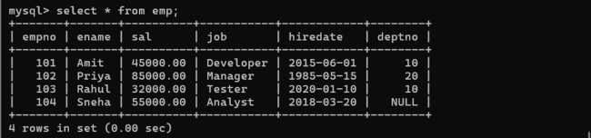3.
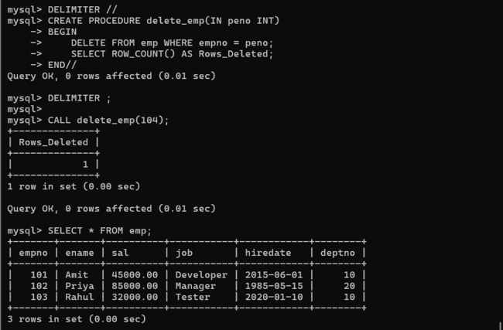
4.
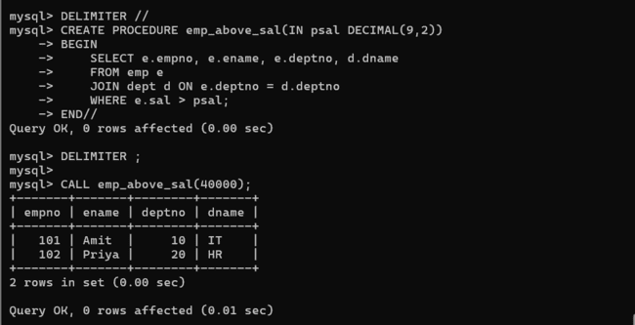
5.
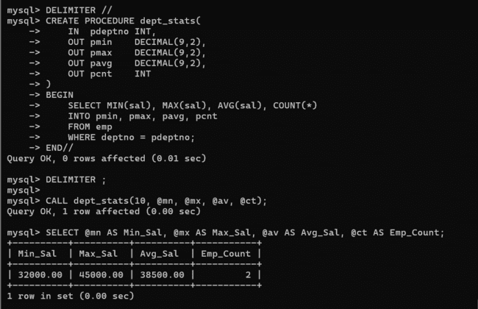
6.
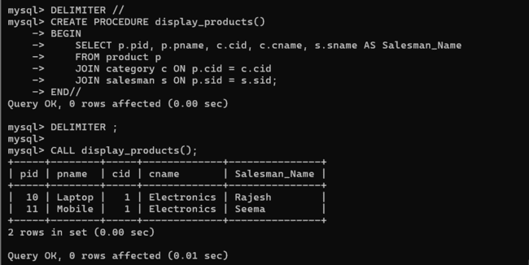
7.
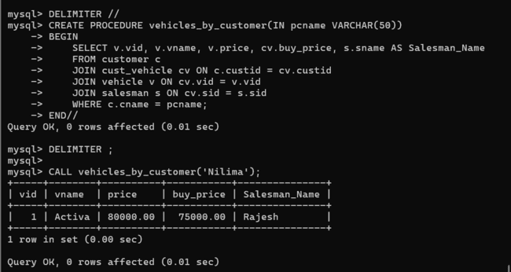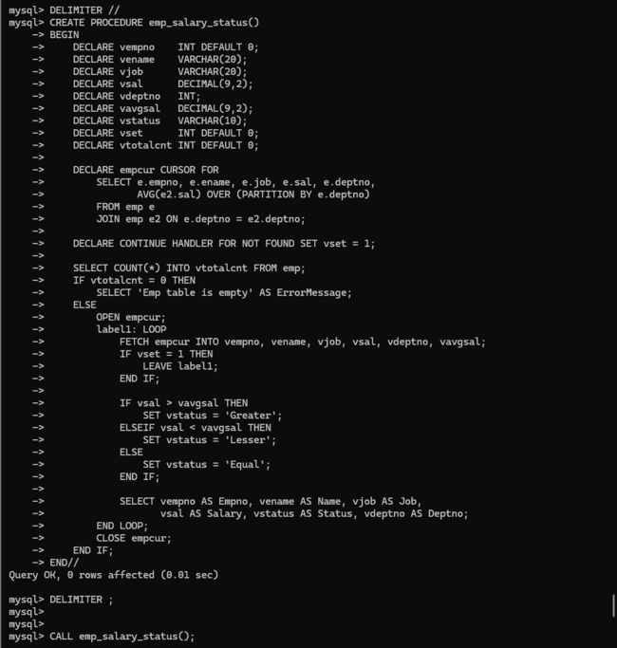
8.
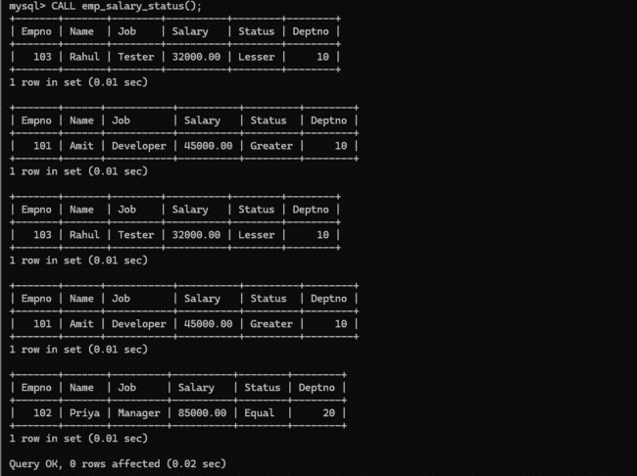
9.
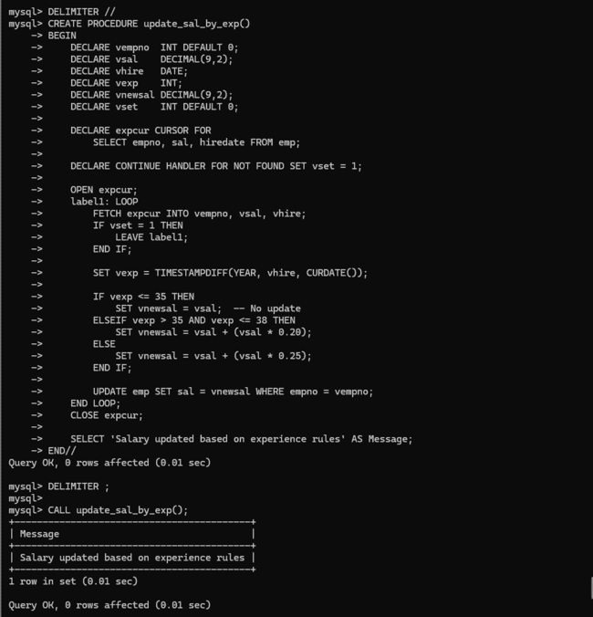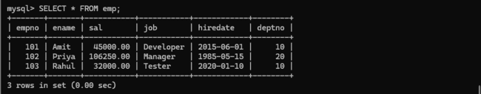
10.
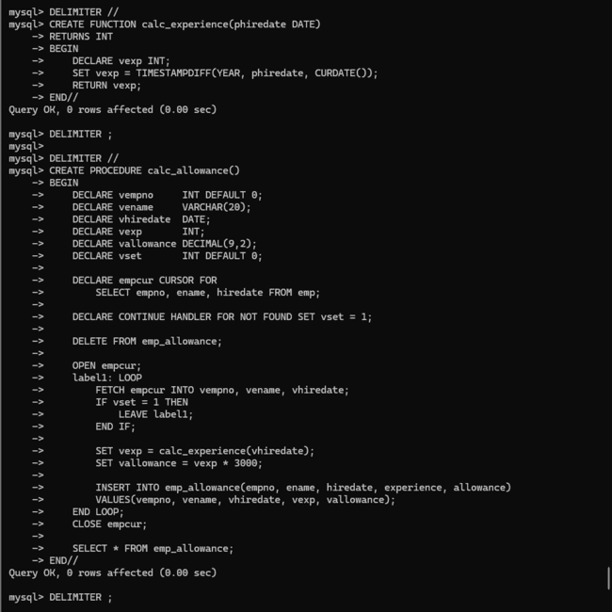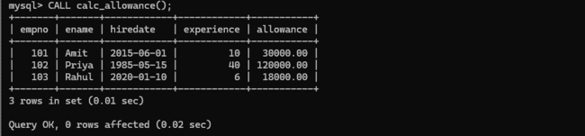
11.
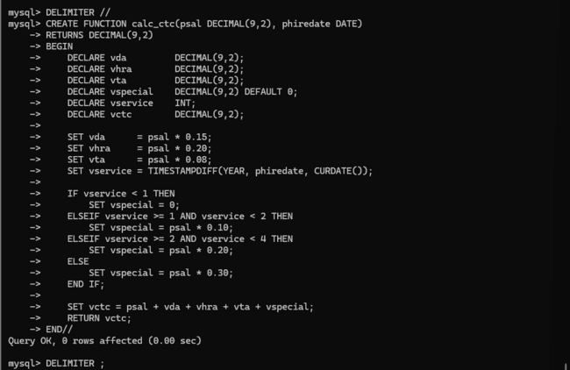
12.
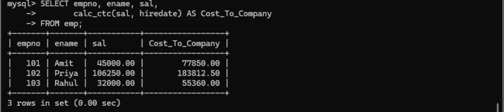
QUESTION 2. (Triggers)

1.
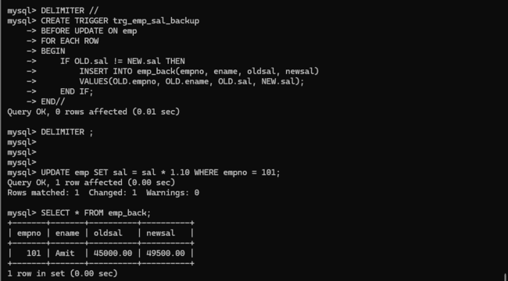
2.
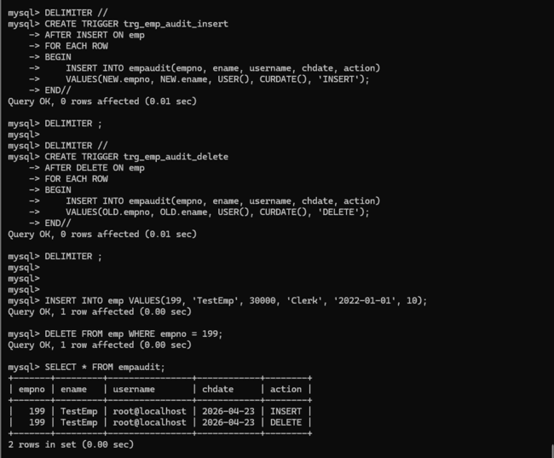
3.
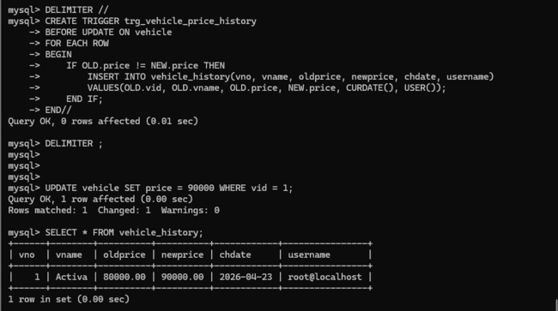

(Day 11)
Q1.

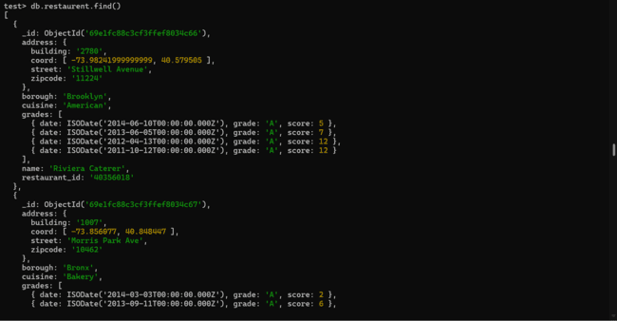
Q2.
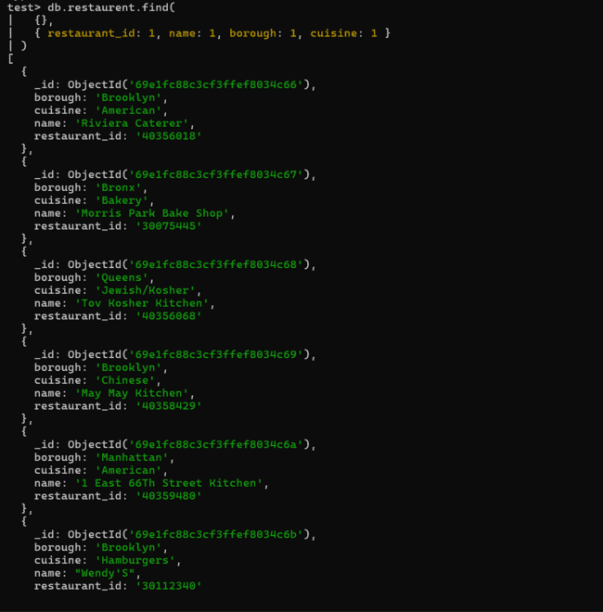
Q3.
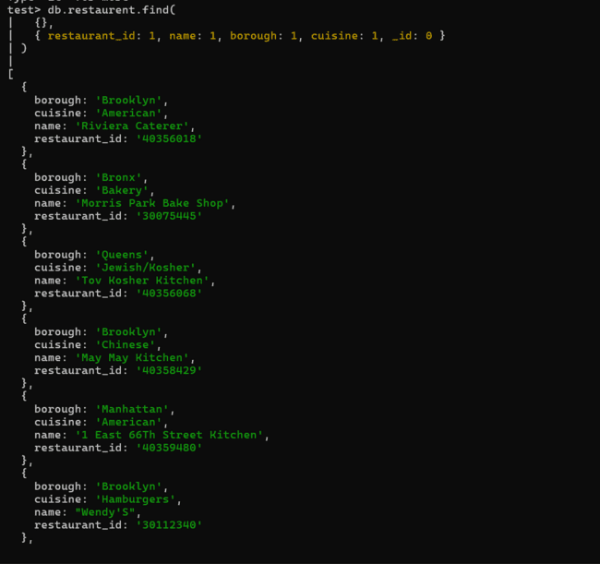
Q4.
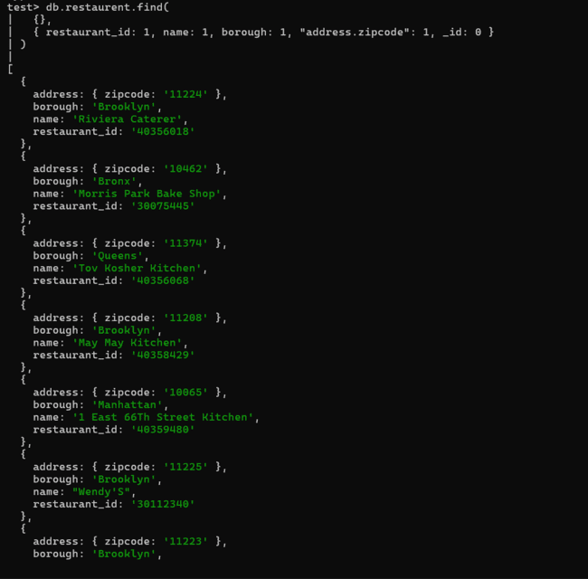
Q5.
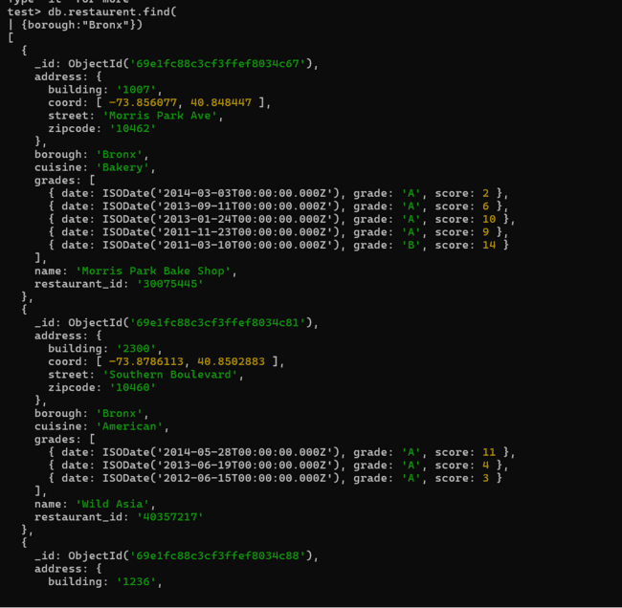
Q6.
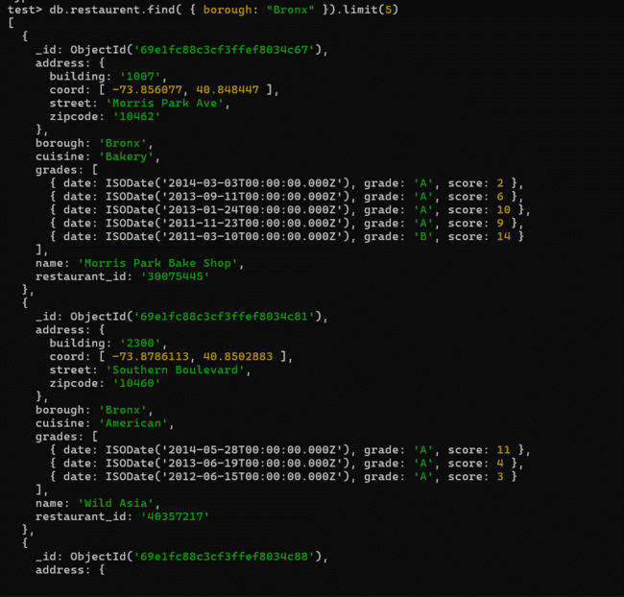
Q7.
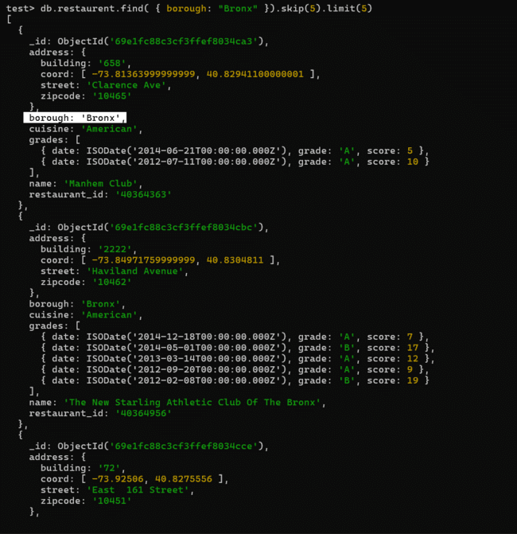
Q8.
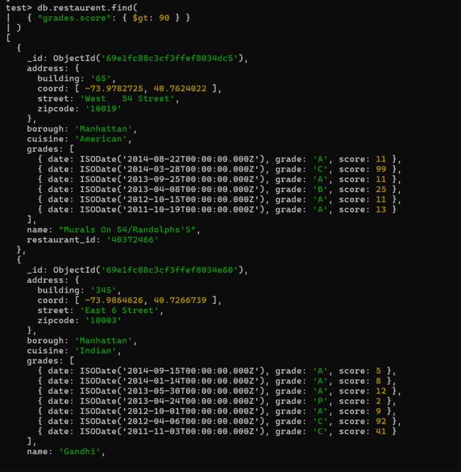
Q9.
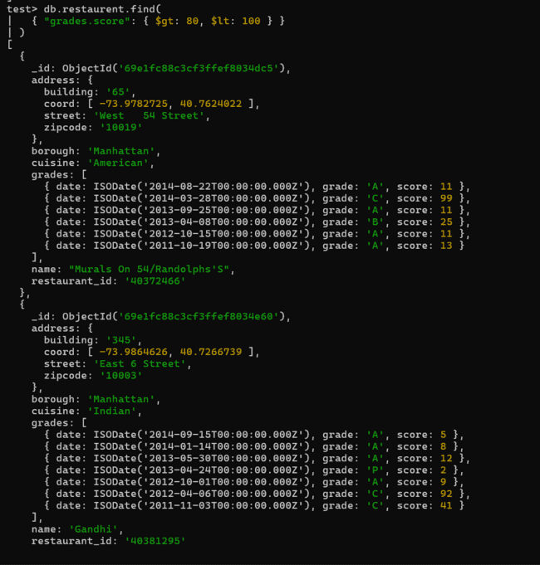
Q10.
Q11.
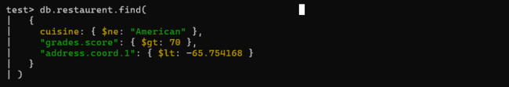
Q12.
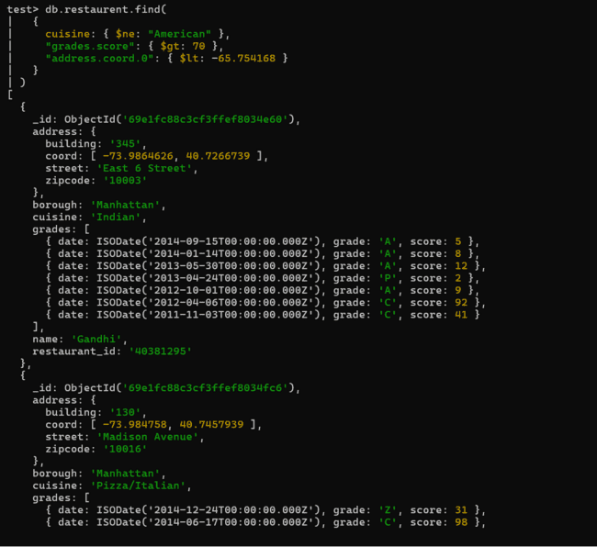
Q13.
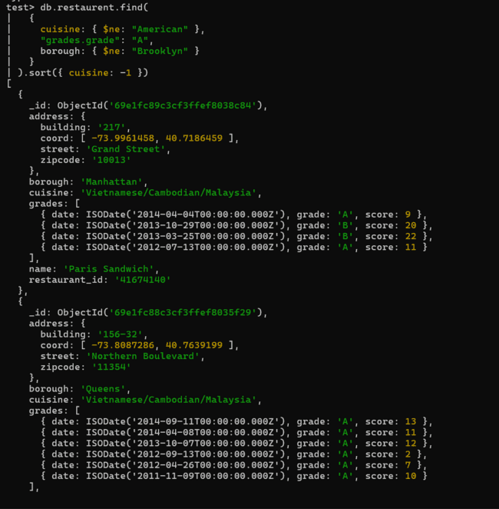
Q14.
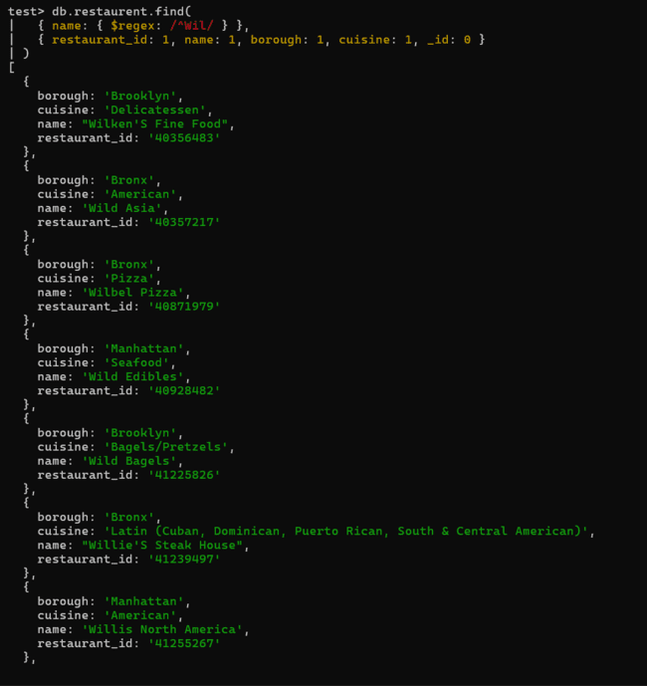
Q15.
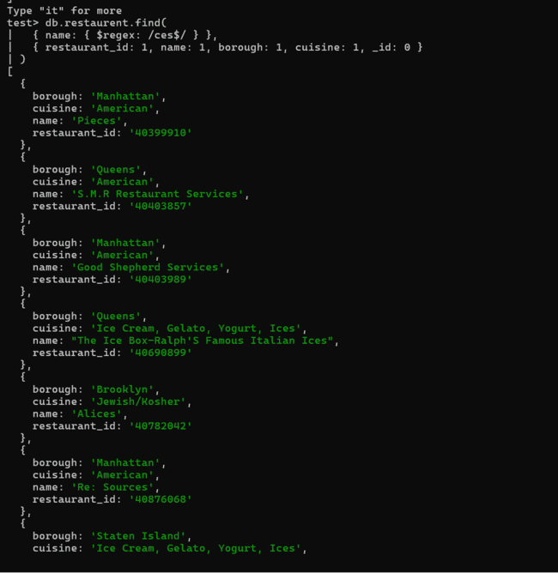
Q16.
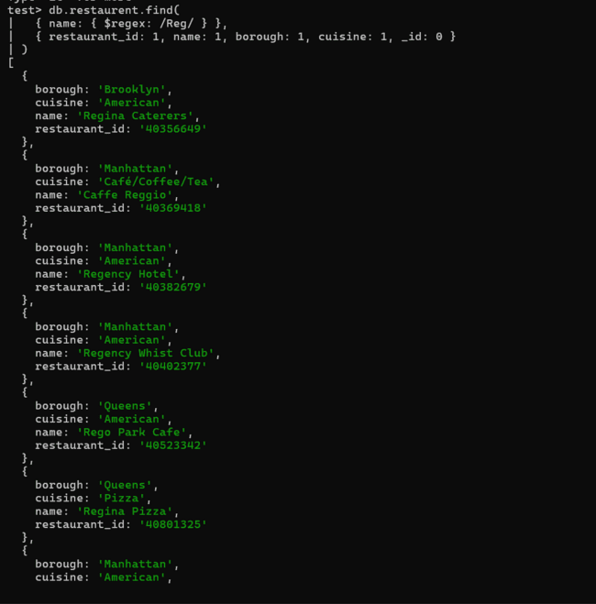
Q17.
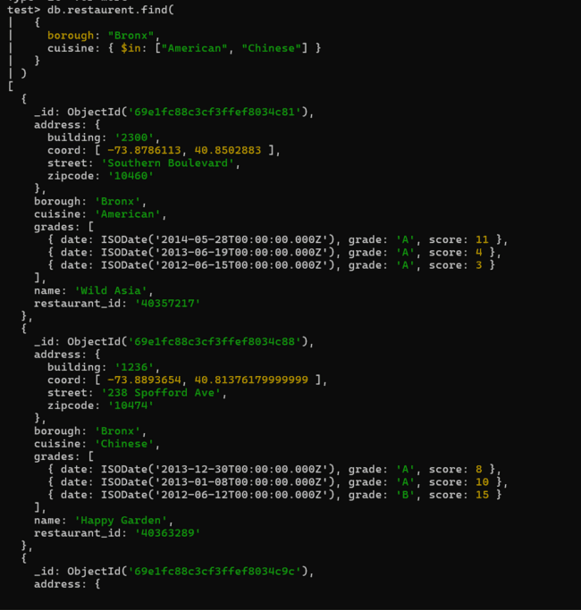
Q18.
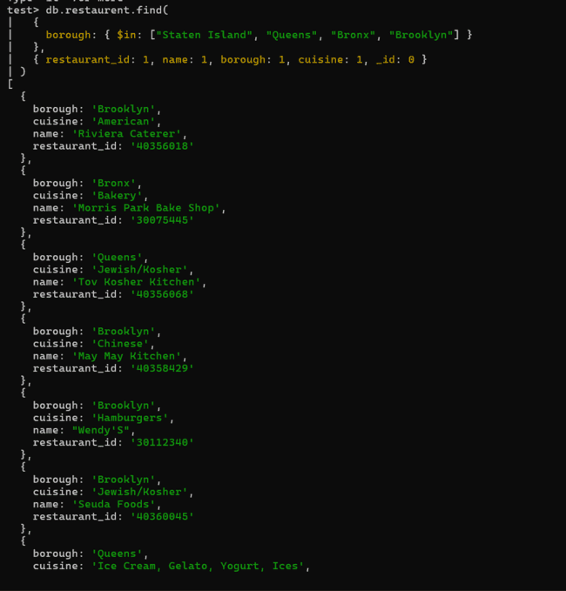
Q19.
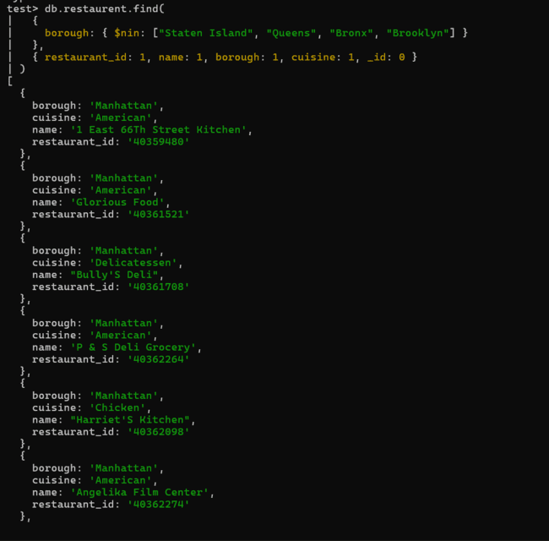
Q20.
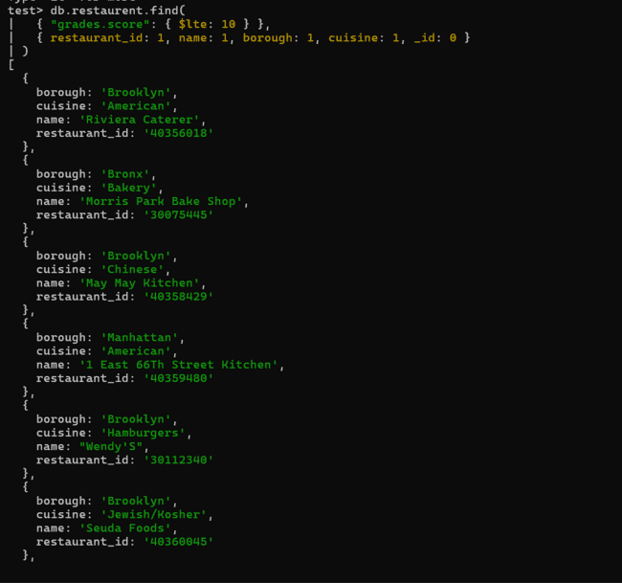
Q21.
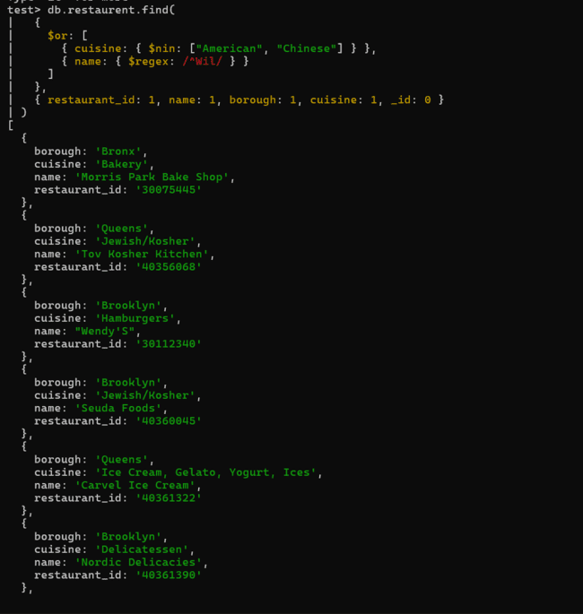
Q22.
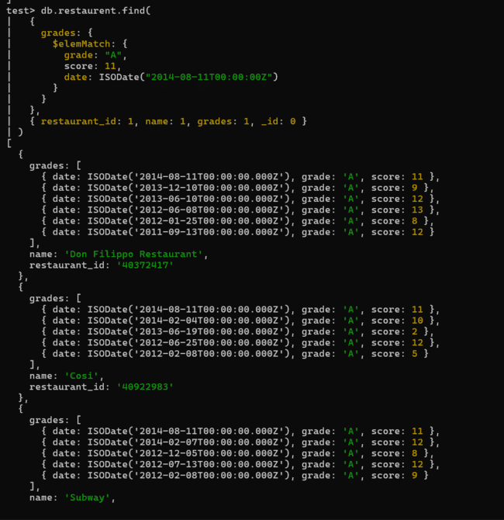
Q23.
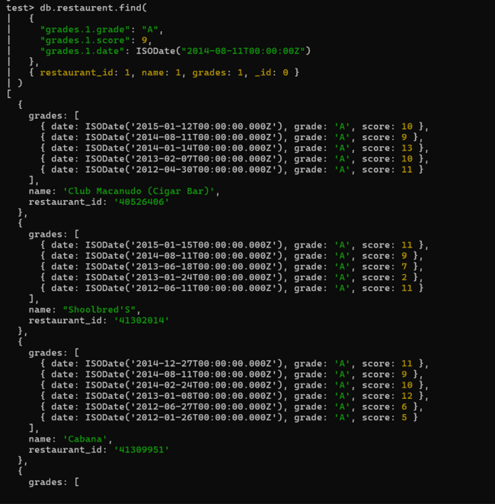
Q24.
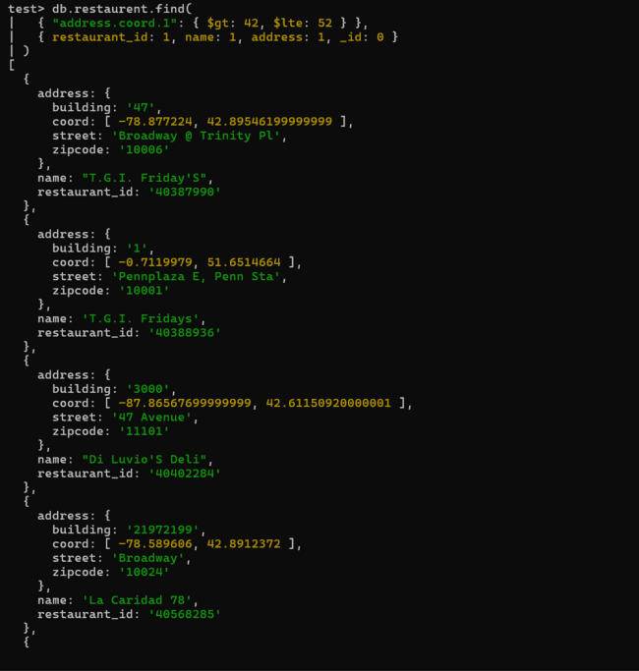
Q25.
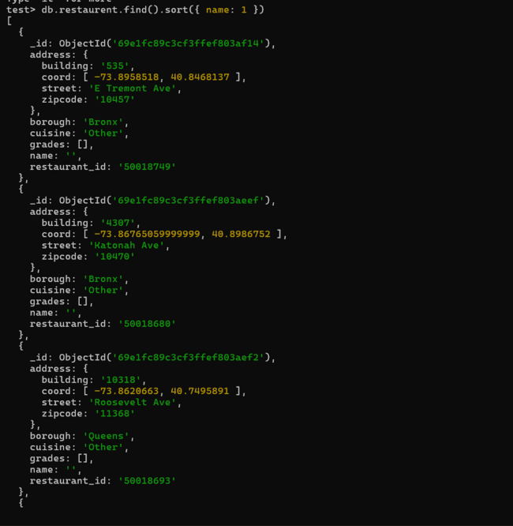
Q26.
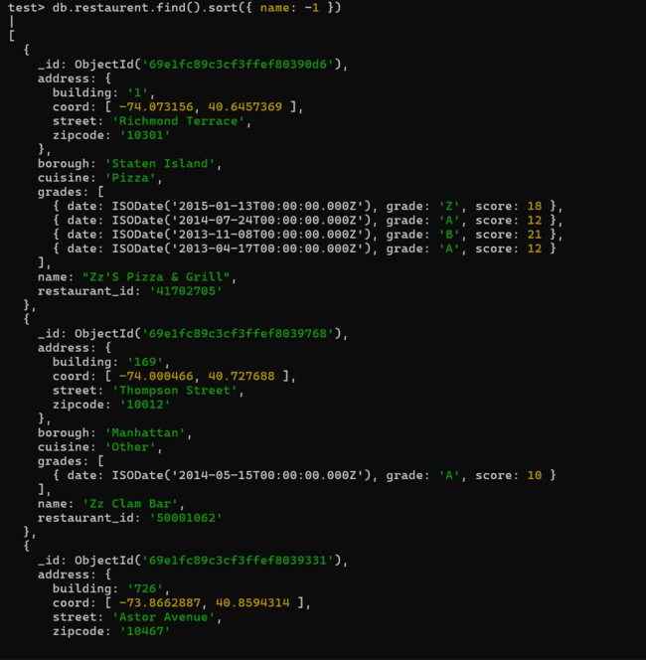
Q27.
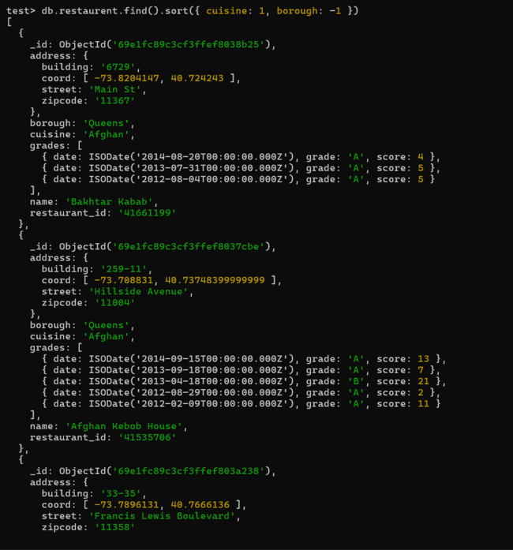
Q28.

Q29.
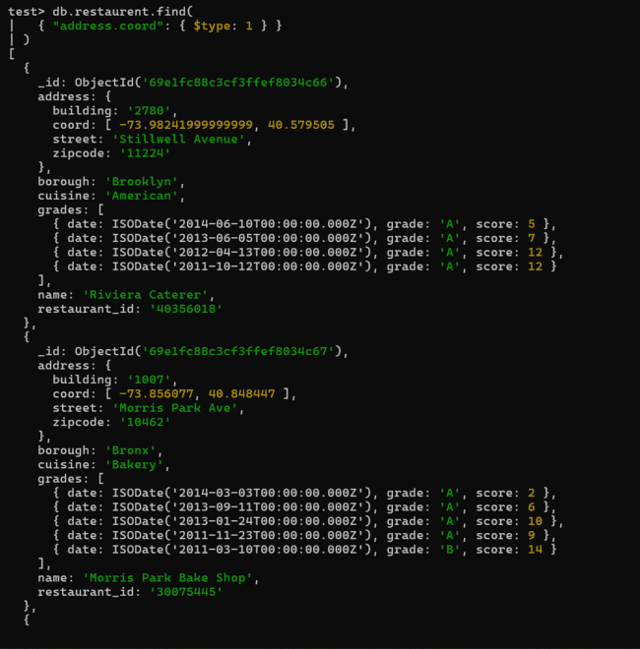
Q30.
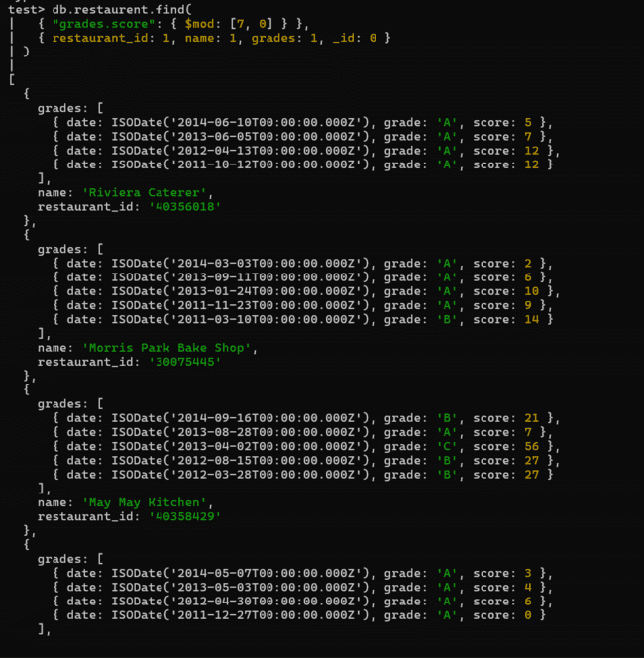
Q31.
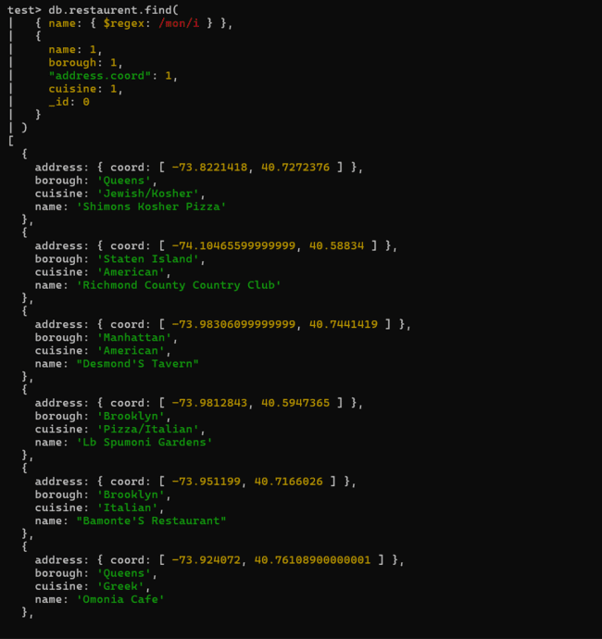
Q32.
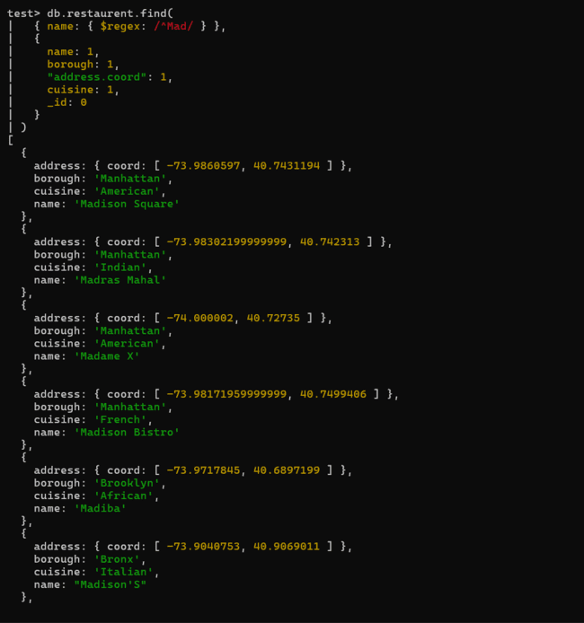
(DAY 12)
Create a Employee Collection add 5 documents:
Example:
{empno:111,
ename:"Deepali Vaidya",
sal:40000.00,
dept:{deptno:12,dname:,"Hr",dloc:"Mumbai"},
Desg:"Analyst",
mgr:{name:"Satish",num:222},
project:[{name:"project-1",Hrs:4},
{name:"project-2",Hrs:4}],
skillset:['perl','python','java'],
hobbies:['reading','biking']}

1. All Employee’s with the desg as ‘CLERK’ are now called as (AO) Administrative Officers. Update the Employee collection for this.
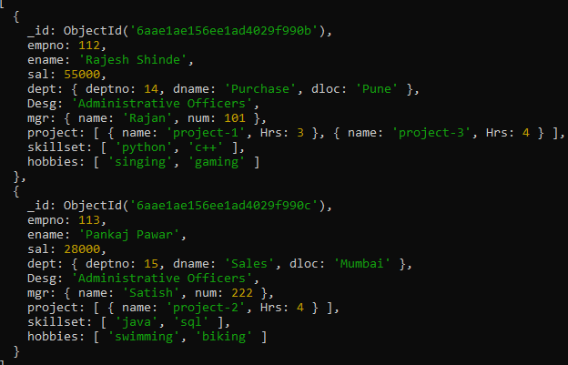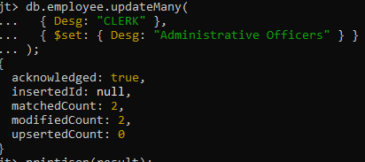
2. Change the number of hours for project-1 to 5 for all employees with designation analyst.
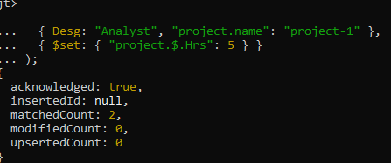
3. Add 2 projects project-3 and project-4 for employee whose name starts with ”Deep” with 2 hrs
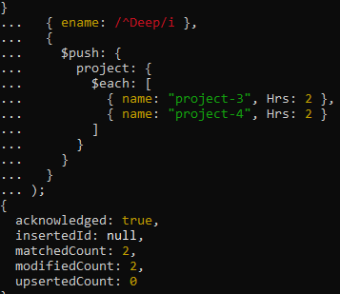
4. Add bonus rs 2000 for all employees with salary > 50000
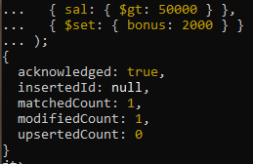

5. Add bonus rs 1500 if salary <50000 and > 30000
db.Employee.updateMany({sal:{$gt:30000,$lt:50000}},{$set:{bonus:1500}});
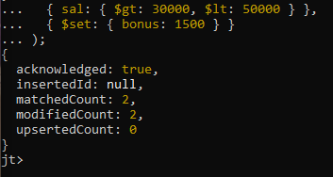

6. increment bounus by 1000 for all employees if salary <=30000
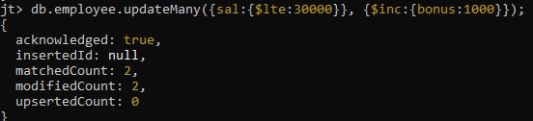
7. Change manager name to Tushar for all employees whose manager is currently “satish” And manager number to 3333
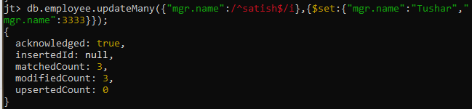
8. Increase salary of all employees from “purchase department” by 15000
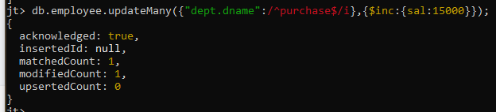

9. Decrease number of hrs by 2 for all employees who are working on project-2
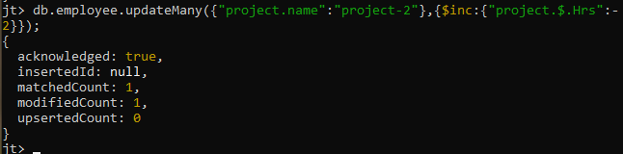
10. Delete project-2 from all employee document if they are working on the project for 4
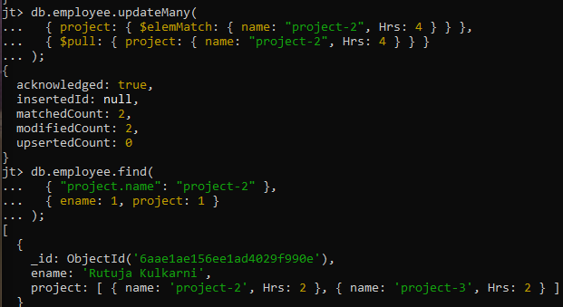
11. Change the salary of employees to 10000 only if their salary is < 10000
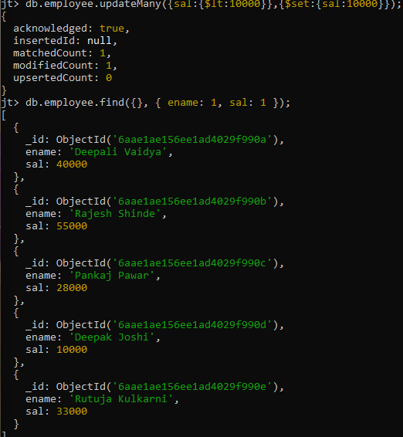
12. Increase bonus of all employees by 500 if the bonus is <2000 or their salary is < 20000 or if employee belong to sales department
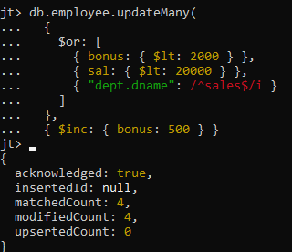
13. Add 2 new project at position 2 for all employees with designation analyst or salary is equal to either 30000 or 33000 or 35000
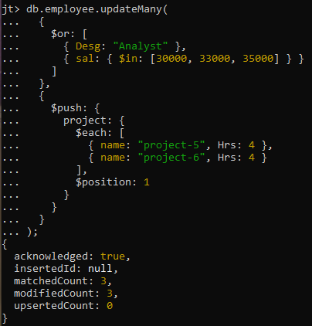

14. Delete last project of all employees with department name is “HR” and if the location is Mumbai
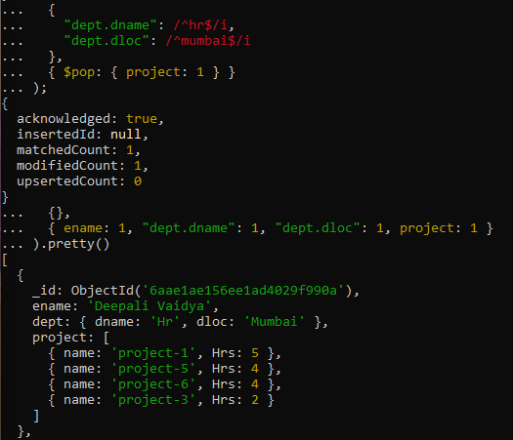
15. Change designation of all employees to senior programmer if they are working on name:”Project-1” for 4 hrs
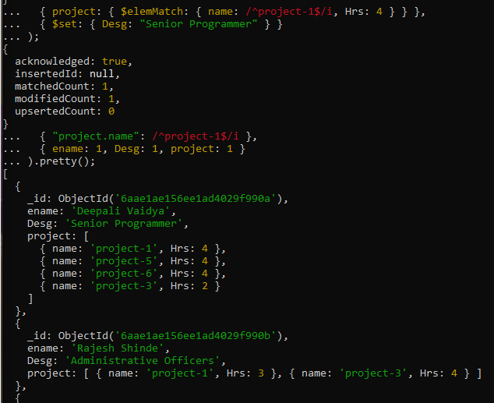
16. Add list of hobbies in all employees document whose manager is Rajan or Revati
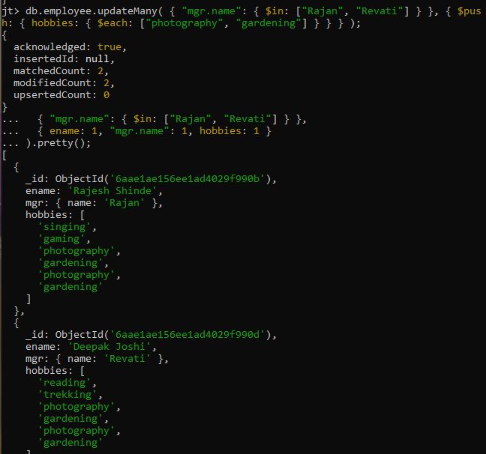
17. Add list of skillset in all employee documents who are working on project-4 for 3 hrs or on project-3 for 4 hrs
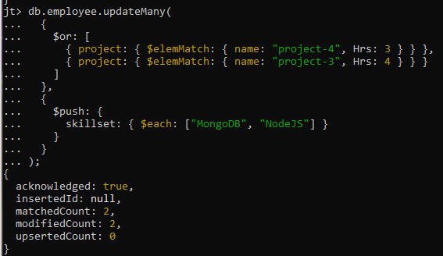

18. Add a new hobby as blogging at 3 position in hobbies array for all employess whose name starts with R or p and ends with j or s
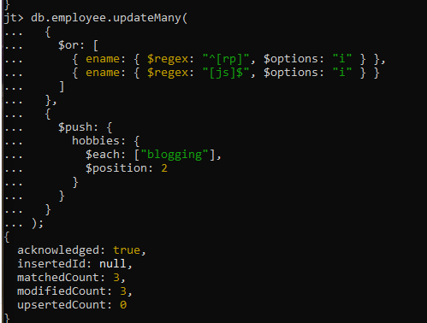

19. Increase salary by 10000 for all employees who are working on project-2 or project-3 or project-1
Decrease bonus by 1000 rs And increase salary by 1000rs for all employees whose department location is Mumbai
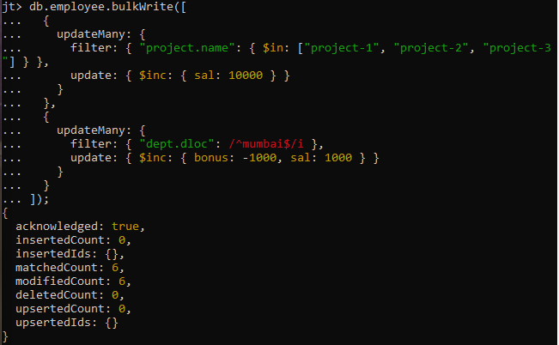

20. Remove all employees working on project-1
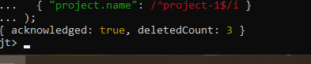
21. Replace document of employee with name “Deepak to some new document
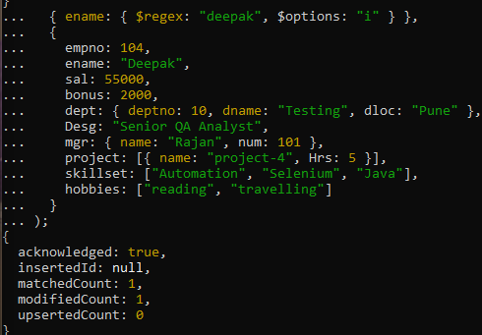

22. Change skill python to python 3.8 for all employees if python is there in the skillset
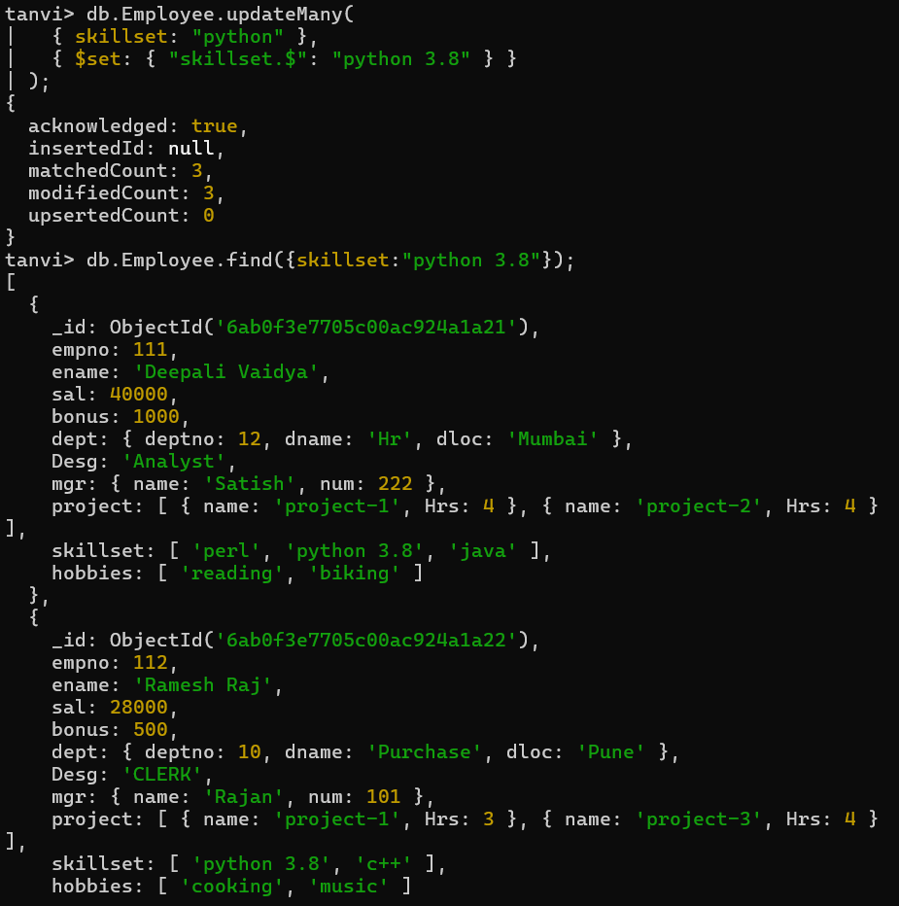

23. Add 2 skills MongoDb and Perl at the end of skillset array for all employees who are working at Pune location
db.Employee.updateMany(
{ "dept.dloc": { $regex: "^pune$", $options: "i" } },
{ $set: { skillset: ["mongoDb", "Perl"] } }
);
db.Employee.find({dept.dloc:pune});
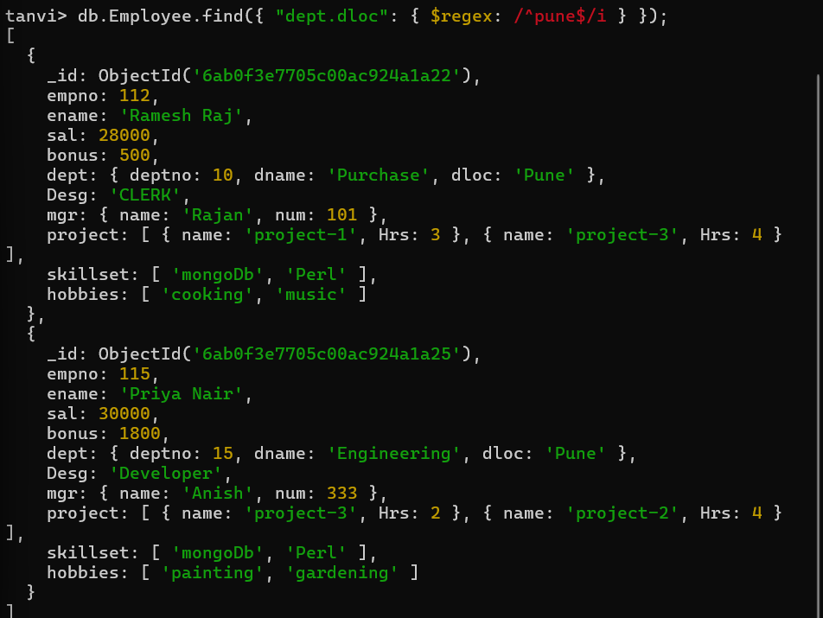

24. Delete first hobby from hobby array for all employees who are working on project-1 or project-2
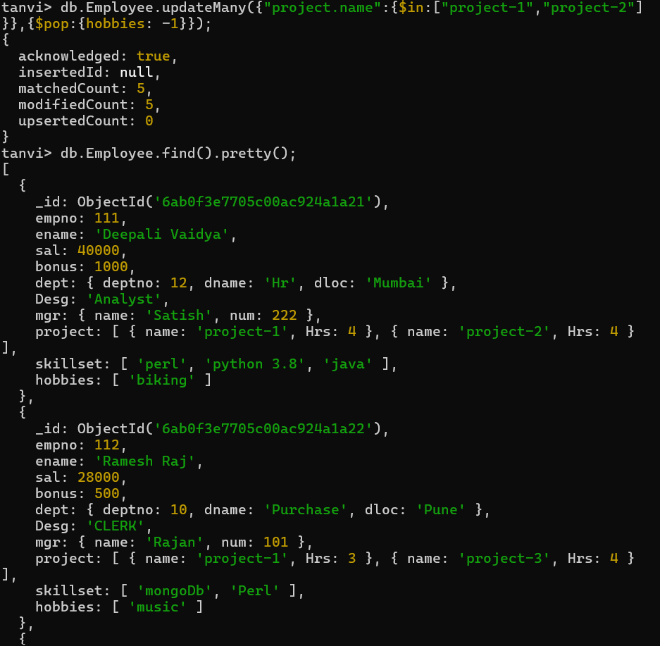
25. Delete last hobby from hobbies array for all employees who are working on project which is at 2 nd position in projects array for 4 hrs
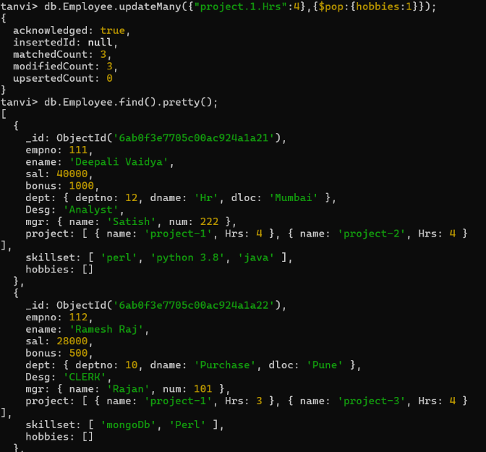

26. Add 2 new projects at the end of array for all employees whose skillset contains Perl or python
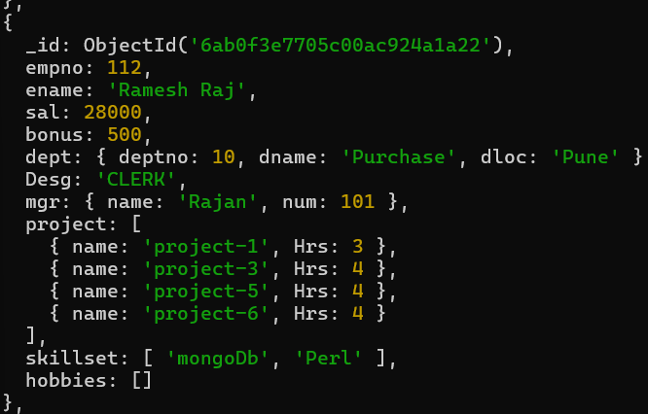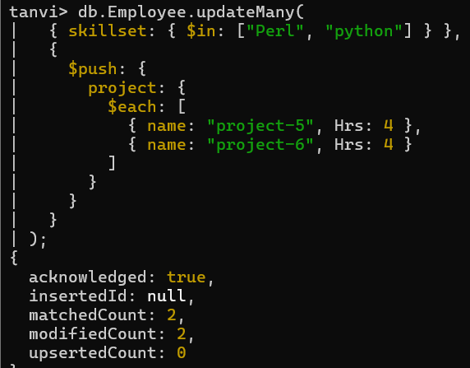

27. Change hrs to 6 for project-1 for all employees if they working on the project-1 for < 6 hrs. otherwise keep the existing value.


